Authored By: Mallory Schroeder

**TABLE OF CONTENTS Page**

**1.** **REFERENCES 1**

**2. abstract 1**

**3. objective 2**

**4. protocol DEVIATIONS 2**

**5. results 2**

**6. discussion 6**

**7. conclusions 7**

# REFERENCES

|  |  |
| --- | --- |
| ENG-PRT-451 | Zip Pen Requirement Verification Protocol |
| MKT-CMR-029 | MEGADYNE Smoke Evacuation Product Line CMR |
| MKT-US-002 | Usability Requirements Specification, Smoke Evacuation Pencils, Extension Nozzles and Universal ULPA Filter |
| ENG-PS-007 | Product Specification, Smoke Evacuation Pencil and Accessories |
| ENG-PS-010 | Product Specification, Disposable Electrosurgical Pencil |
| ENG-IOM-014 | Input/Output Conformance Test Matrix: Disposable Electrosurgical Pencil |

# abstract

Zip Pen samples were subjected to a testing outlined in ENG-PRT-451. The samples passed the acceptance criteria described in ENG-PRT-451, verifying customer and marketing level (MKT-CMR-029), usability (MKT-US-002) and product specification (ENG-PS-007) requirements that are not tested under other protocols. This pertains to the Zip Pen products identified in MKT-CMR-029, including cat numbers 2525-10 (252510), 2525-10EC (252510EC), 2525-10BN (252510BN), 2525-10ECBN (252510ECBN), 2525-15EC (252515EC), and 2525-15 (252515), ME7251C, ME7251E, ME725M1C, ME725M1E. These Zip products share the same design, differing only in cord / tubing length, active electrode type, and/or packaging. This protocol also pertains to the Extension Nozzle cat numbers 2540 (2540J) and 2560 (2560J), connector filter/tubing 2140 (2140J), and ULPA Filter 2211 (2211J) The catalog numbers in parentheses are new catalog numbers referring to the same product, due to transition of product information from Megadyne Medical Products to Ethicon Endo Surgery. The old and new catalog numbers are interchangeable as it relates to referencing a product.

# objective

The purpose of this test protocol is to document conformance to requirements of customer and marketing (MKT-CMR-029), usability (MKT-US-002) and product specification (ENG-PS-007) that are not verified under other protocols.

# protocol DEVIATIONS

Two deviations were made from the protocol. Plug extraction force testing was not completed here, as an equivalent test has already been conducted in R150215 Section 5.7 and R150216 section 5.8 per P-140308-E-3 and P140311-E-2 respectively. These are New Deantronics documents and housed in their quality system. See ENG-IOM-014 for the results. While a different product the plug is the same. The requirement for plug extraction is a minimum of 2lb per ENG-PS-010. The Zip product spec ENG-PS-007 is being updated from a minimum of 6lb to a minimum of 2lb to remain consistent across Megadyne product lines.

An additional ESU, Covidien FT10, was tested for physical plug compatibility. As mentioned in ENG-PRT-451, there is no specification of exact ESUs which must be compatible, but MKT-CMR-029 states that the Zip Pen will have a standard three-prong plug and be compatible with most standard ESUs in the market. As an additional ESU was available, it was included in this testing to further fulfill this requirement.

# results

Testing was conducted on February 13, 2018 by Mallory Schroeder and Paul Valpreda at Megadyne Medical Products (11506 State St, Draper, UT 84020). Zip Pen samples were tested, with samples noted in ENG-PRT-451 under ‘Experiment Design / Sample Size Justification.’ Training was conducted, with the record found in Appendix XIV. All data is found in Appendix I - XIII.

* 1. Cable & Tube Length, Connector Dimension, Swivel Distance

Three (3) samples of each Zip Pen (252510EC and 252515) were measured to find the Cable Length, Tube Length, and Swivel Distance using a measuring tape. The ID of the 22mm Connector found on three (3) samples of 252510EC was measured using calipers. See results in the following table:

|  |  |  |  |  |  |  |  |  |
| --- | --- | --- | --- | --- | --- | --- | --- | --- |
| Catalog Number | Cable Length | | Tube Length | | ID of Connector | | Swivel Distance | |
| Criteria | Measured (in.) | Criteria | Measured (in.) | Criteria | Measured (in.) | Criteria | Measured (in.) |
| 252510EC | 120+/-6in | 114.3/114.5/115 | 120+/-2.6in | 119/120.2/119.8 | .875+/-.005in | .874/.878/.877 | 8+/-1in | 8.125/8.125/8.125 |
| 252515 | 180+/-6in | 174/174.3/174.1 | 176+/-3.6in | 176/177/178 | .875+/-.005in | See 252510EC | 8+/-1in | 8.25/8.1/7.9 |

See Appendix I for raw data.

* 1. E-Z Clean Coating

Electrode from Catalog #2525-10EC Lot #1511014 was coated with E-Z Clean coating. Electrode from Catalog #2525-15 Lot #S170066 was coated with E-Z Clean coating. See Appendix II for raw data.

* 1. Holster, Plug, Cord Color

The Holster from Catalog #2525-15 Lot #S160050 is Pantone 427.

The Plug from Catalog #2525-15 Lot #S160050 is Pantone 427.

The Cord from Catalog #2525-15 Lot #S160050 is Pantone 427.

Parts from Catalog #2525-15 Lot #S160050 match drawing 6020312 Rev 007.

See Appendix III for raw data.

* 1. Plug Branding

The plug clam shell from Catalog #2525-10EC Lot #1511014 has ‘MEGADYNE’ branding and matches drawing 6020312 Rev 007.

See Appendix IV for raw data.

* 1. Angled Nozzle, Clarity

The Nozzle from Catalog #2525-15 Lot #S160050 was angled, clear (not opaque), and matched drawing 5800104-01 Rev 003.

The Nozzle from Catalog #2540 Lot #1507123 was angled, clear (not opaque), and matched drawing 5800309 Rev 002.

The Nozzle from Catalog #2560 Lot #1507124 was angled, clear (not opaque), and matched drawing 5800308 Rev 002. See Appendix V for raw data.

* 1. Cord Exit, Tube Containment Length

Three (3) samples of each Zip Pen (252510EC and 252515) were measured to find the Cord Length Exiting Tube and Tube Containment length using a measuring tape. See results in the following table:

|  |  |  |  |  |  |
| --- | --- | --- | --- | --- | --- |
| Catalog Number | Lot Number | Cord Length Exiting Tube | | Tube Containment Length | |
| Criteria | Measured (in.) | Criteria | Measured (in.) |
| 252510EC | 1511014 | greater than 48 in. | 49.8/50/50.2 | greater than 64 in. | 64.4/65/64.6 |
| 252515 | S170066 | greater than 48 in. | 108.3/108.9/109.1 | greater than 64 in. | 65.2/65.3/65.1 |

See Appendix VI for raw data.

* 1. Cord Containment

Paper was wrapped around the cable in 11 of 11 samples of Catalog #2525-15 Lot #S160050 and matched drawing 6020191-01 Rev 005.

The cord was wrapped and contained within the holster in 11 of 11 samples of Catalog #2525-15 Lot #S160050 and matched drawing 6020191-01 Rev 005.

See Appendix VII for raw data.

* 1. ESU Plug Compatibility

A plug from Catalog #2525-15 Lot# S160050 was successfully inserted into eight (8) different Electrosurgical Units (ESU). See Appendix VIII for a list of ESUs and data.

* 1. Plug Extraction Force

Not tested – See Protocol Deviations.

* 1. Extension Nozzle Length

Three (3) samples of each extension nozzles (2540 and 2560) were measured using calipers. See results in the following table:

|  |  |  |  |
| --- | --- | --- | --- |
| Catalog Number | Lot Number | Criteria | Measured (in.) |
| 2540 | 1507123 | 2.79+/-.02in | 2.779/2.775/2.776 |
| 2560 | 1507124 | 5.29+/-.02in | 5.272/5.273/5.275 |

See Appendix IX for raw data.

* 1. 2211 ULPA Filter Attachment

The threaded connector of Catalog # 2140 Lot #172763 was successfully threaded with Catalog #2211 Lot #15169 and found to be compatible.

See Appendix X for raw data.

* 1. EC Connector Instron Pull Test

The EC Connector was removed from the 7/8” port of a smoke filter using an Instron. The Maximum force measured was 7.16 lbf, the minimum force measured was 4.86 lbf, and the mean force measured was 6.18 lbf with a standard deviation of 0.668 lbf. Of the eleven (11) samples tested, seven (7) failed by the tubing coming off of the connector, while four (4) did not disconnect, the tubing merely stretched. All samples passed the 4 lbf requirement.

See Appendix XI for raw data.

* 1. Cable, Plug Cytotoxicity

Both the Cable (ND Part # C302600) and Plug (New Deantronics Part # F507100, F507200 or F505100, F505200) of the Zip Pen have demonstrated acceptable biocompatibility.

The cable jacket material of New Deantronics Part # C302600 is the same material as New Deantronics Part # C103700—Light Gray PVC CTi color code XEU003--- PMS427C, SHORE A, 75 +/- 3 with Plasticizer PN-1030. This jacket material was tested in New Deantronics Report R130811-E. See Appendix XII for cable specifications and test report.

The plug material of New Deantronics Part # F507100, F507200 or F505100, F505200 is the same material as the Zip Pen body (New Deantronics Part #F105400, Megadyne part # 6010135-01-- ABS, Gray Pantone Color 427. This material is tested in ENG-RPT-337 per ENG-PRT-235 and meets biocompatibility requirements. Therefore, the plug also meets biocompatibility requirements.

* 1. 2211 ULPA Filter Efficiency

2211 demonstrates 99.999% efficiency for particles 0.1 to 0.2 micron as specified in 6000019-01 rev 005. See Appendix XIII for Certificate of Compliance from Custom Filter LLC. Test methods used to determine efficiency also attached in Appendix XIII.

# discussion

6.1. Cable & Tube Length, Connector Dimension, Swivel Distance

Three 2525-10EC samples and three 2525-15 samples were examined per the protocol. The requirements of the protocol were met.

6.2. E-Z Clean Coating

One 2525-10EC sample and one 2525-15 sample were examined per the protocol. The requirement of the protocol was met.

6.3. Holster, Plug, Cord Color

One 2525-15 accelerated aged sample was examined per the protocol. The requirement of the protocol was met.

6.4. Plug Branding

One 252515-10EC sample was examined per the protocol. The requirement of the protocol was met.

6.5. Angled Nozzle, Clarity

One accelerated aged 2525-15 sample, one 2540, and one 2560 were examined per the protocol. All samples met the requirements of the protocol.

6.6. Cord Exit, Tube Containment Length

Three samples of both 2525-10EC and 2525-15 were measured per the protocol. All samples met the requirements of the protocol.

6.7. Cord Containment

Eleven accelerated aged and ship tested 2525-15 samples were examined per the protocol. All samples met the requirements of the protocol.

6.8. ESU Plug Compatibility

One accelerated aged and ship tested 2525-15 sample was tested with eight competitive ESUs with standard three-prong plugs per the protocol. The requirement per the protocol was met.

6.9. Plug Extraction Force

Not tested— See Protocol Deviations.

6.10. Extension Nozzle Length

Three samples of both 2540 and 2560 were tested per the protocol. All samples met the requirement of the protocol.

6.11. 2211 ULPA Filter Attachment

One sample of 2211 and 2140 were tested per the protocol. The requirement per the protocol was met.

6.12. EC Connector Instron Pull Test

Eleven samples of 2525-10EC were tested per the protocol. All samples met the requirement of the protocol.

6.13. Cable, Plug Cytotoxicity

Documentation is provided, meeting the requirement of the protocol.

6.14. 2211 ULPA Filter Efficiency

Documentation is provided, meeting the requirement of the protocol.

# conclusions

This testing demonstrates that the Zip Pen meets requirements per ENG-PRT-451.

APPENDIX I. Cable & Tube Length, Connector Dimension, Swivel Distance Acceptance Sheet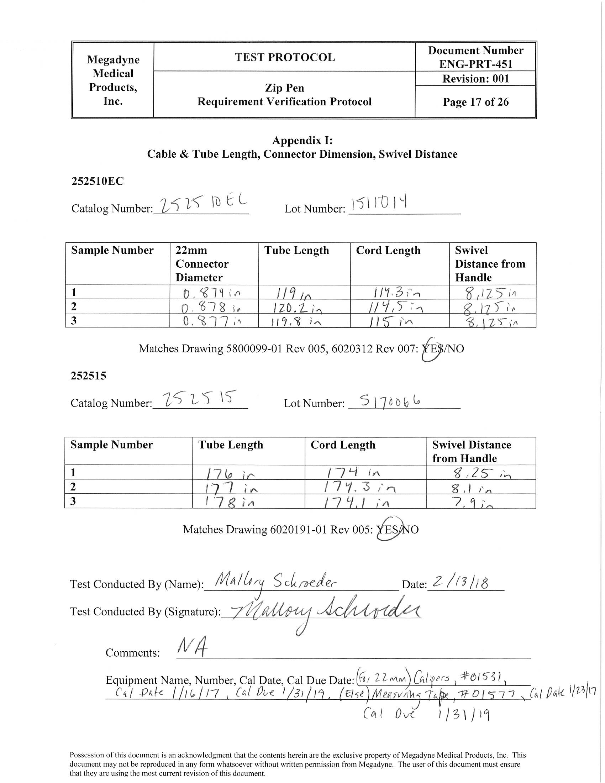

APPENDIX II. E-Z Clean Coating Acceptance Sheet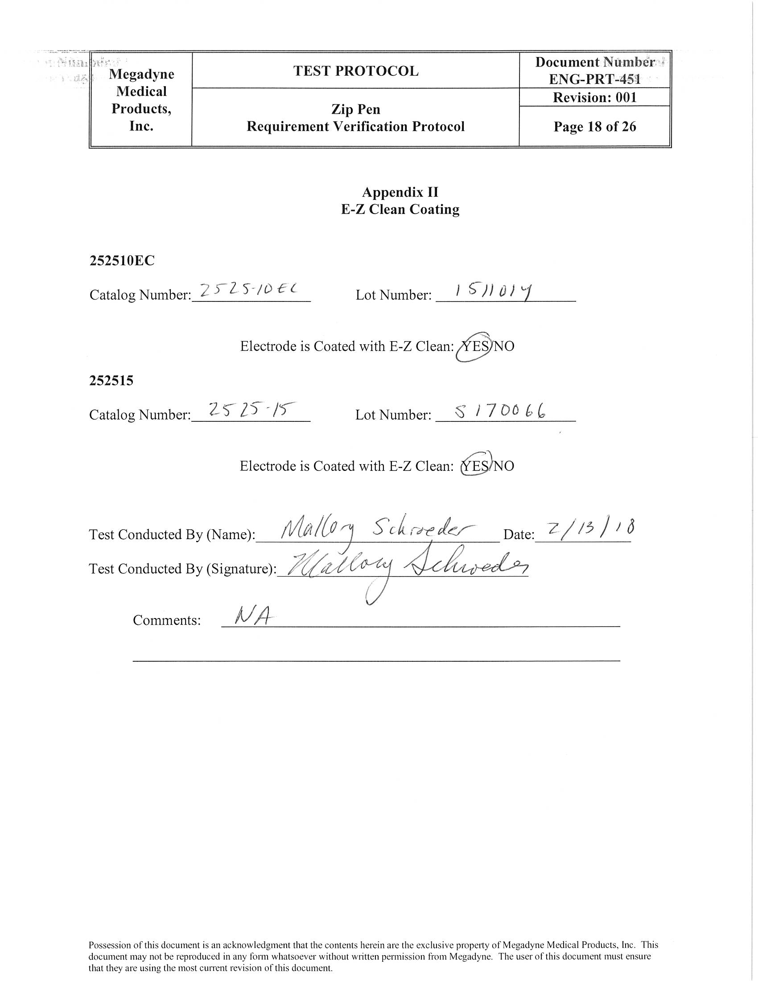

APPENDIX III. Holster, Plug, Cord Color Acceptance Sheet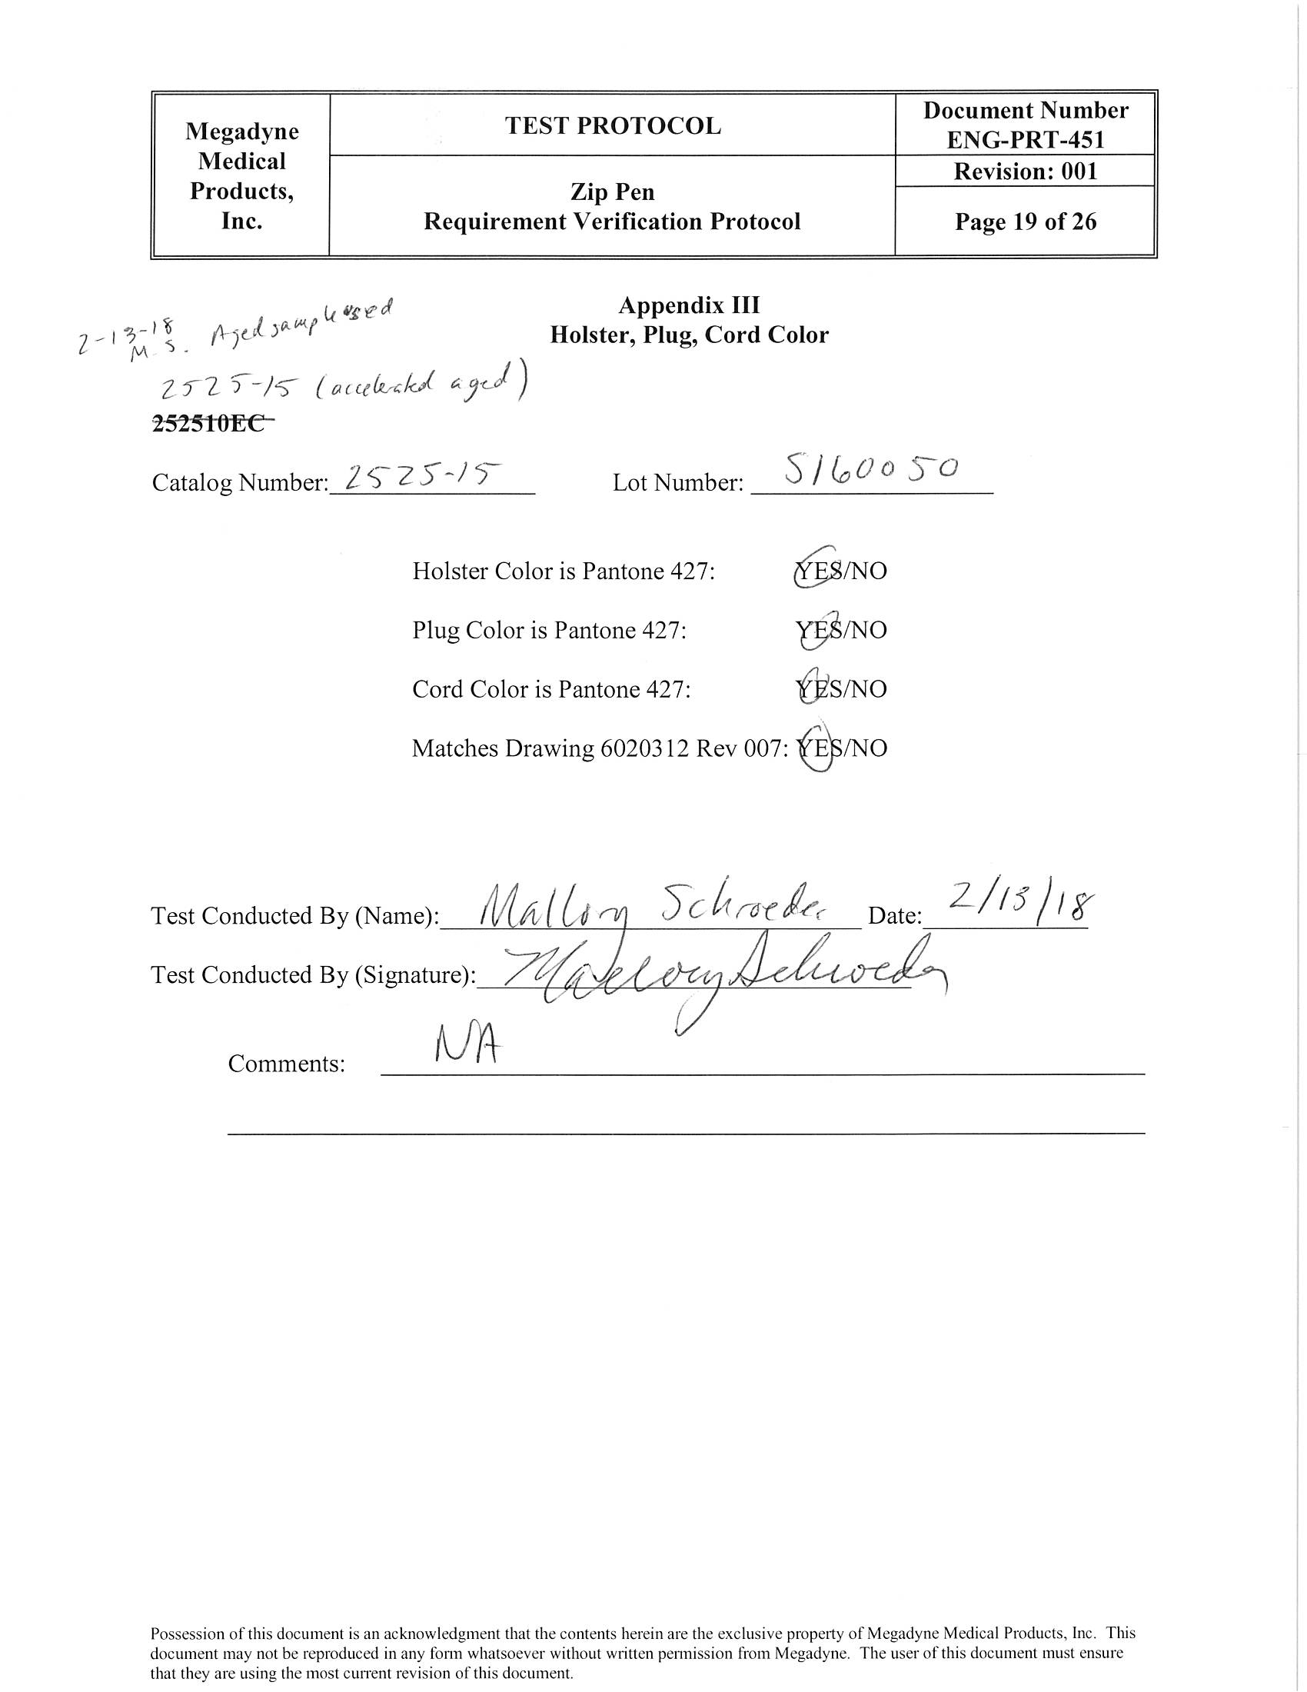

APPENDIX IV. Plug Branding Acceptance Sheet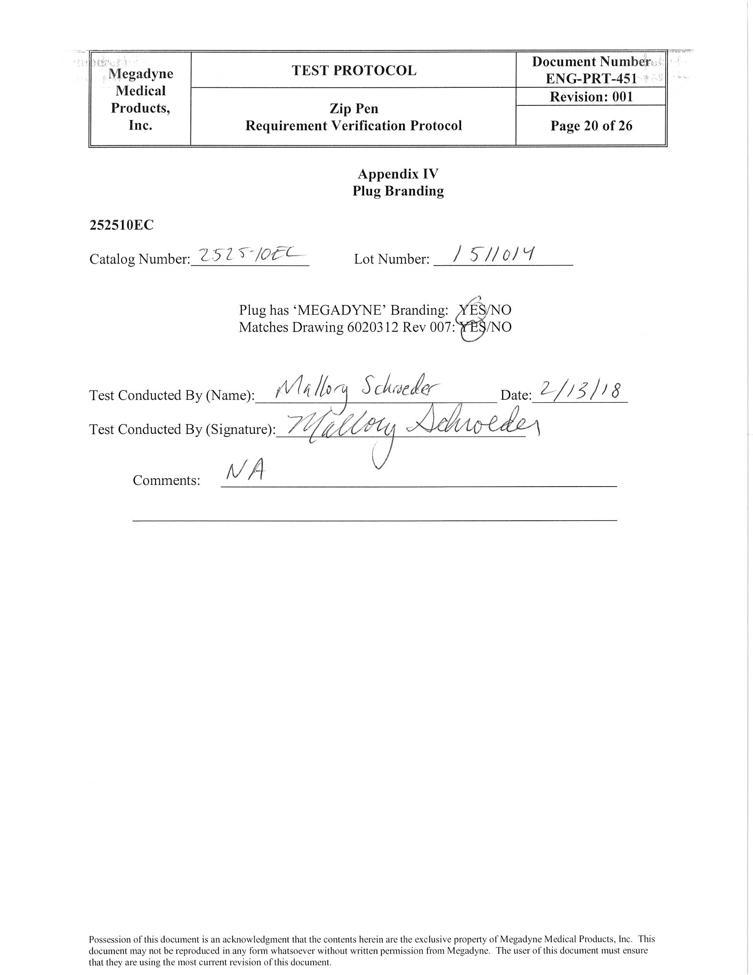

APPENDIX V. Angled, Clarity Nozzle Acceptance Sheet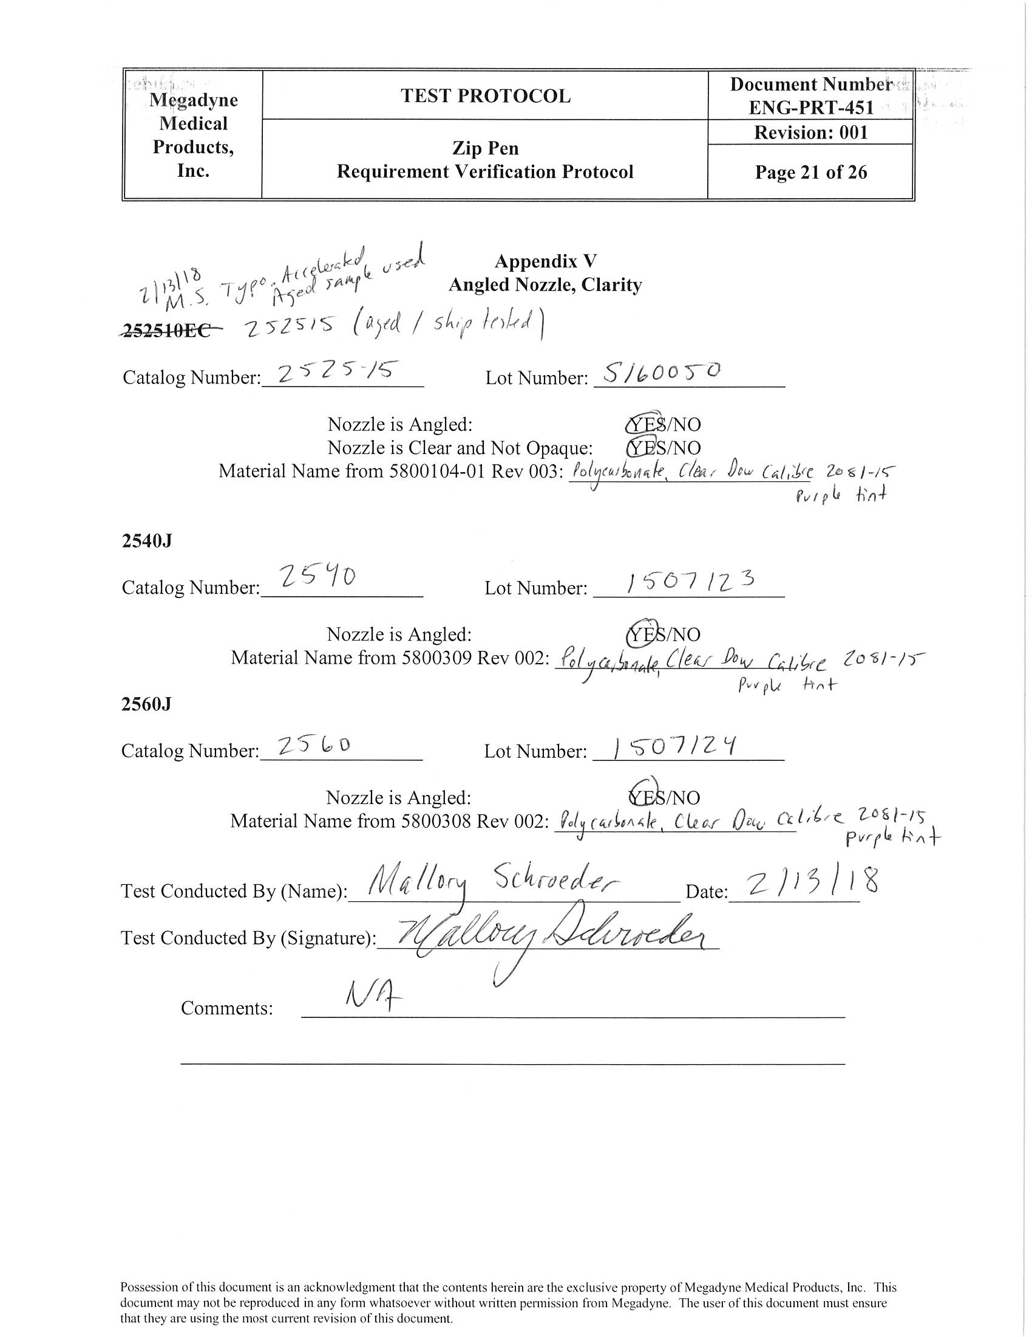

APPENDIX VI. Cord Exit Length Acceptance Sheet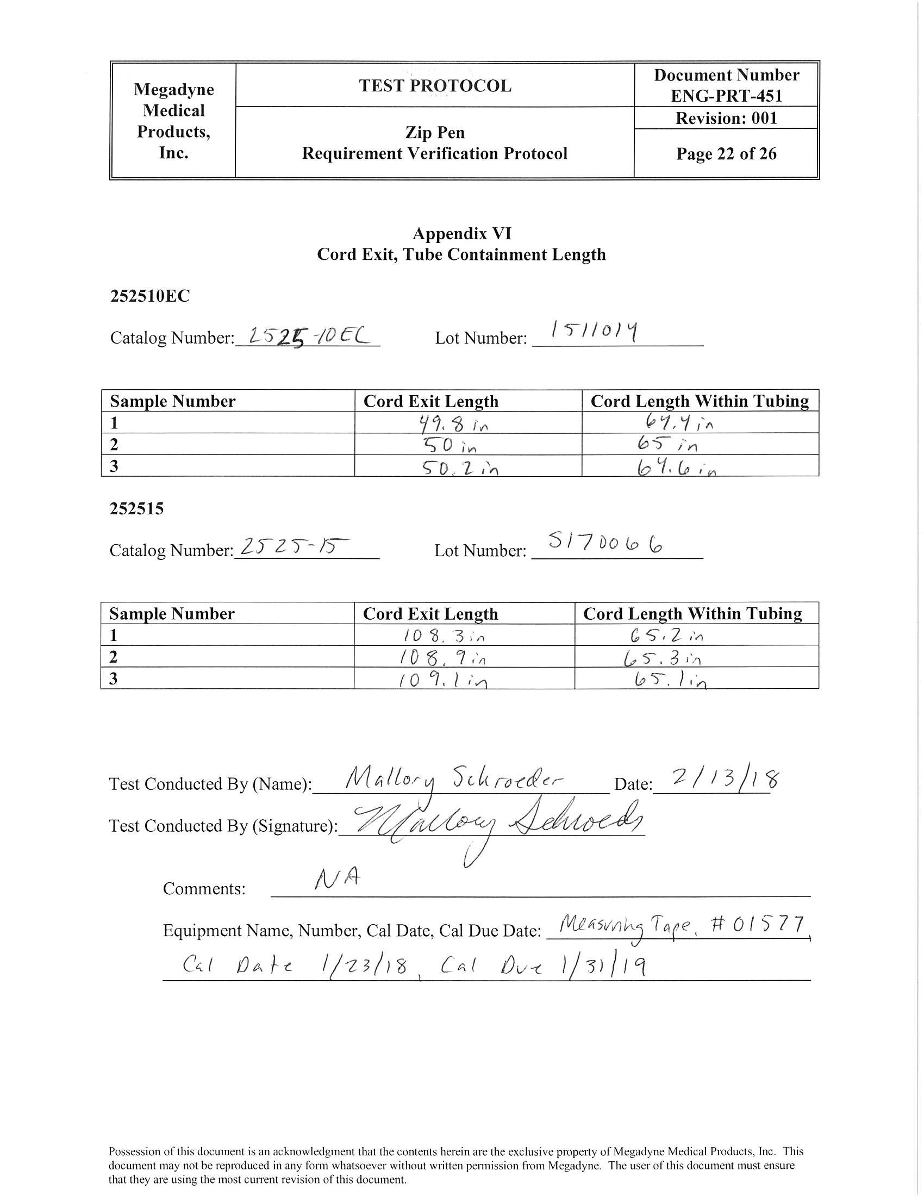

APPENDIX VII. Cord Containment Acceptance Sheet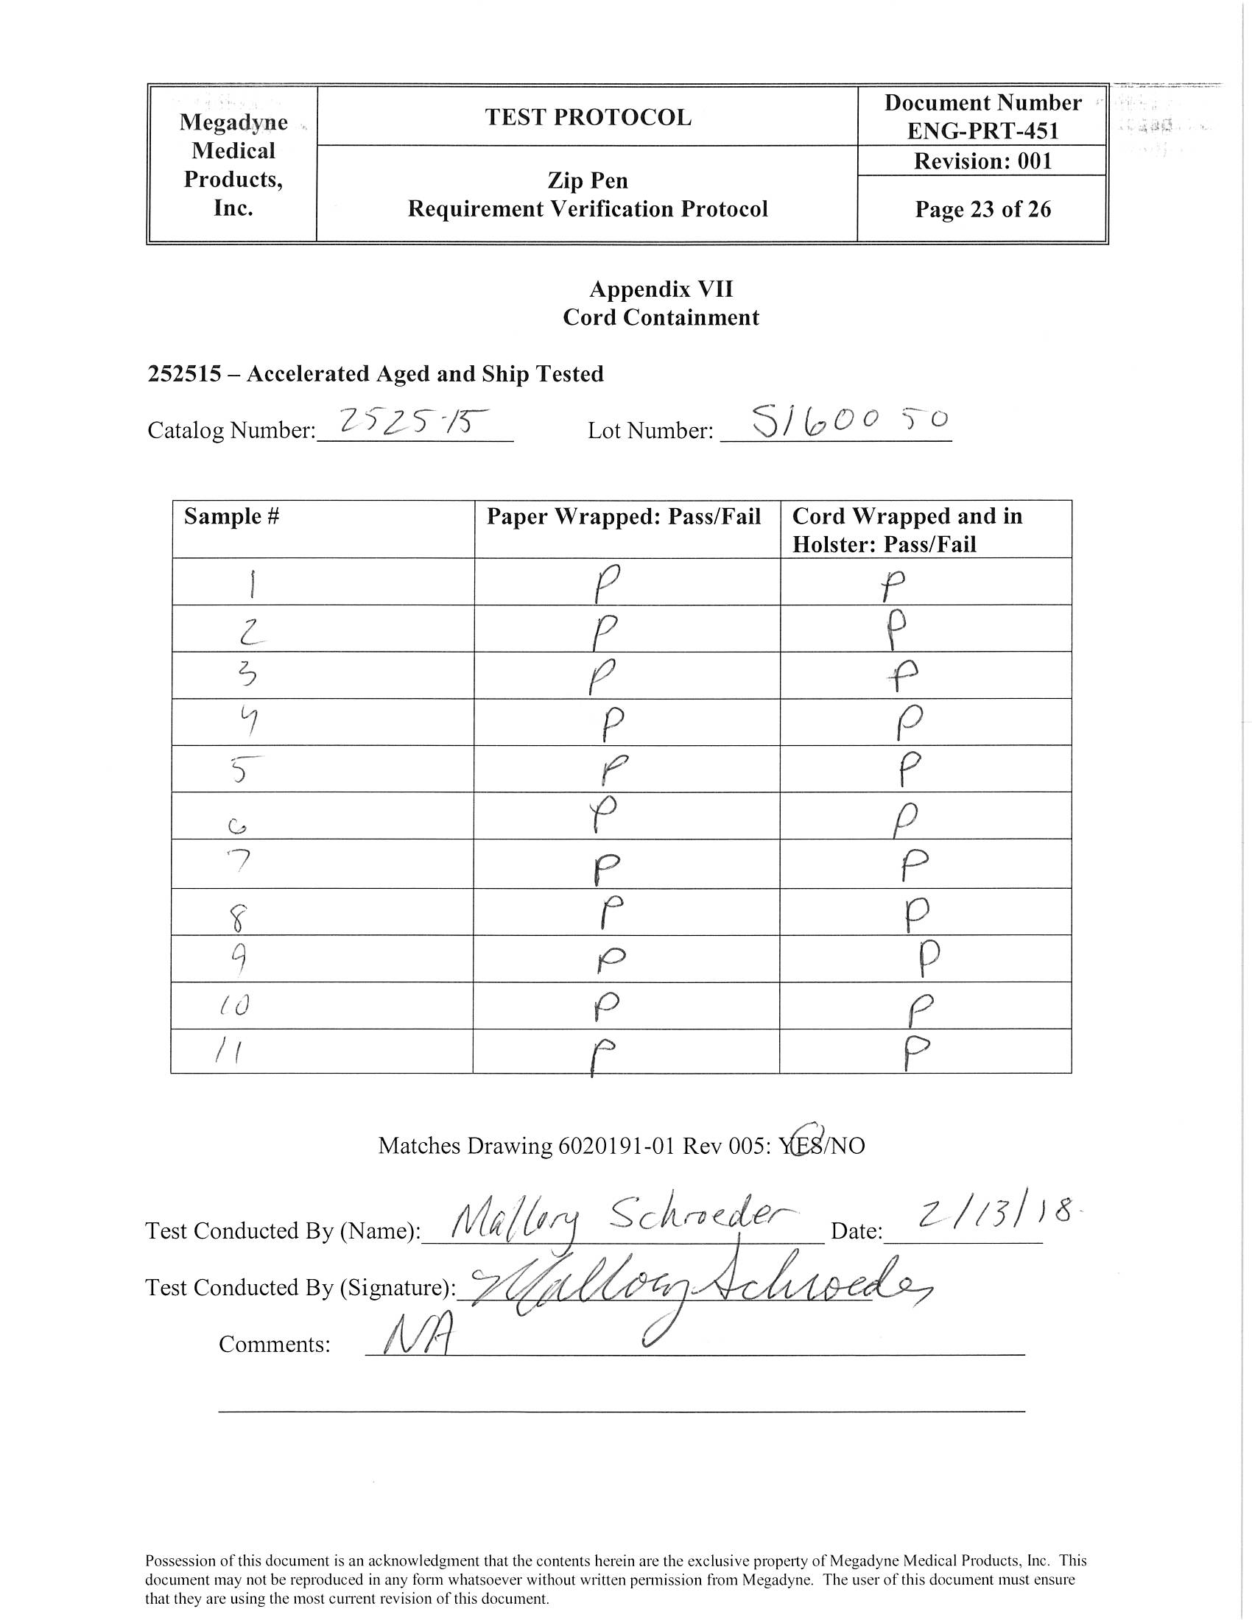

APPENDIX VIII. ESU Physical Plug Compatibility Acceptance Sheet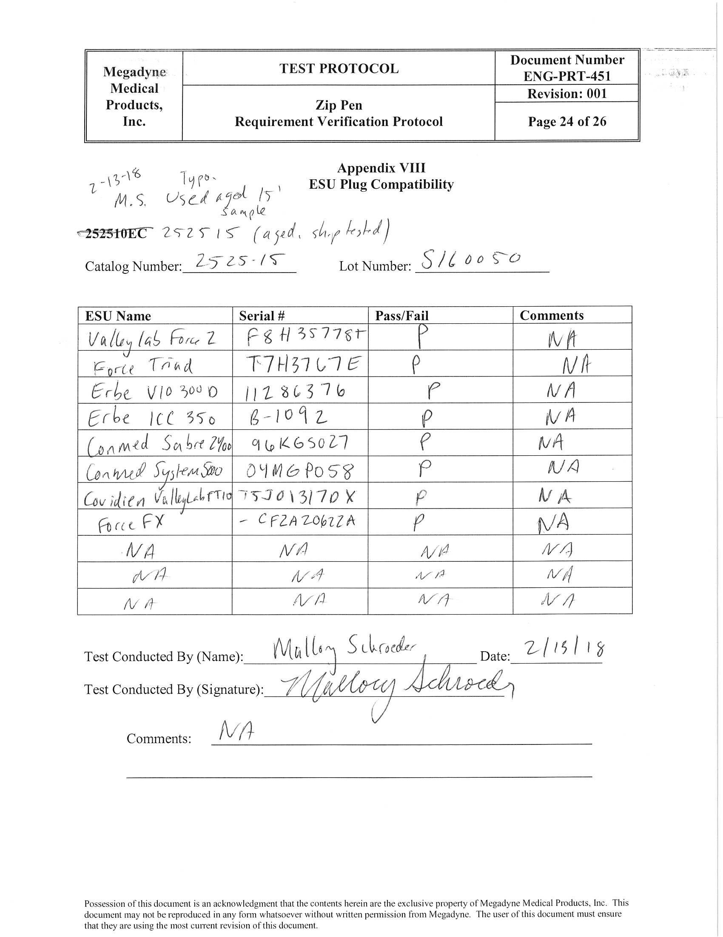

APPENDIX IX. Extension Nozzle Length Acceptance Sheet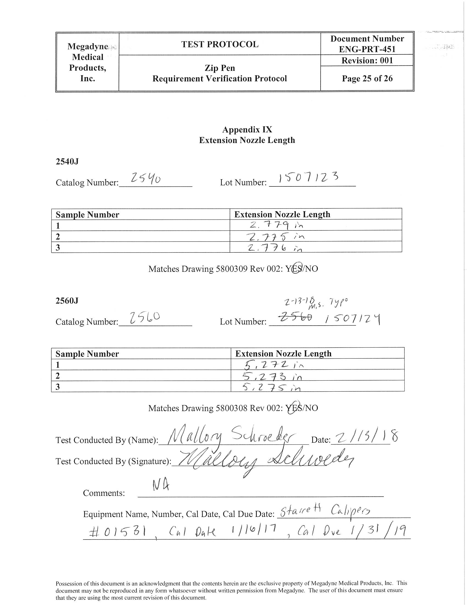

APPENDIX X. 2211 ULPA Filter Attachment Acceptance Sheet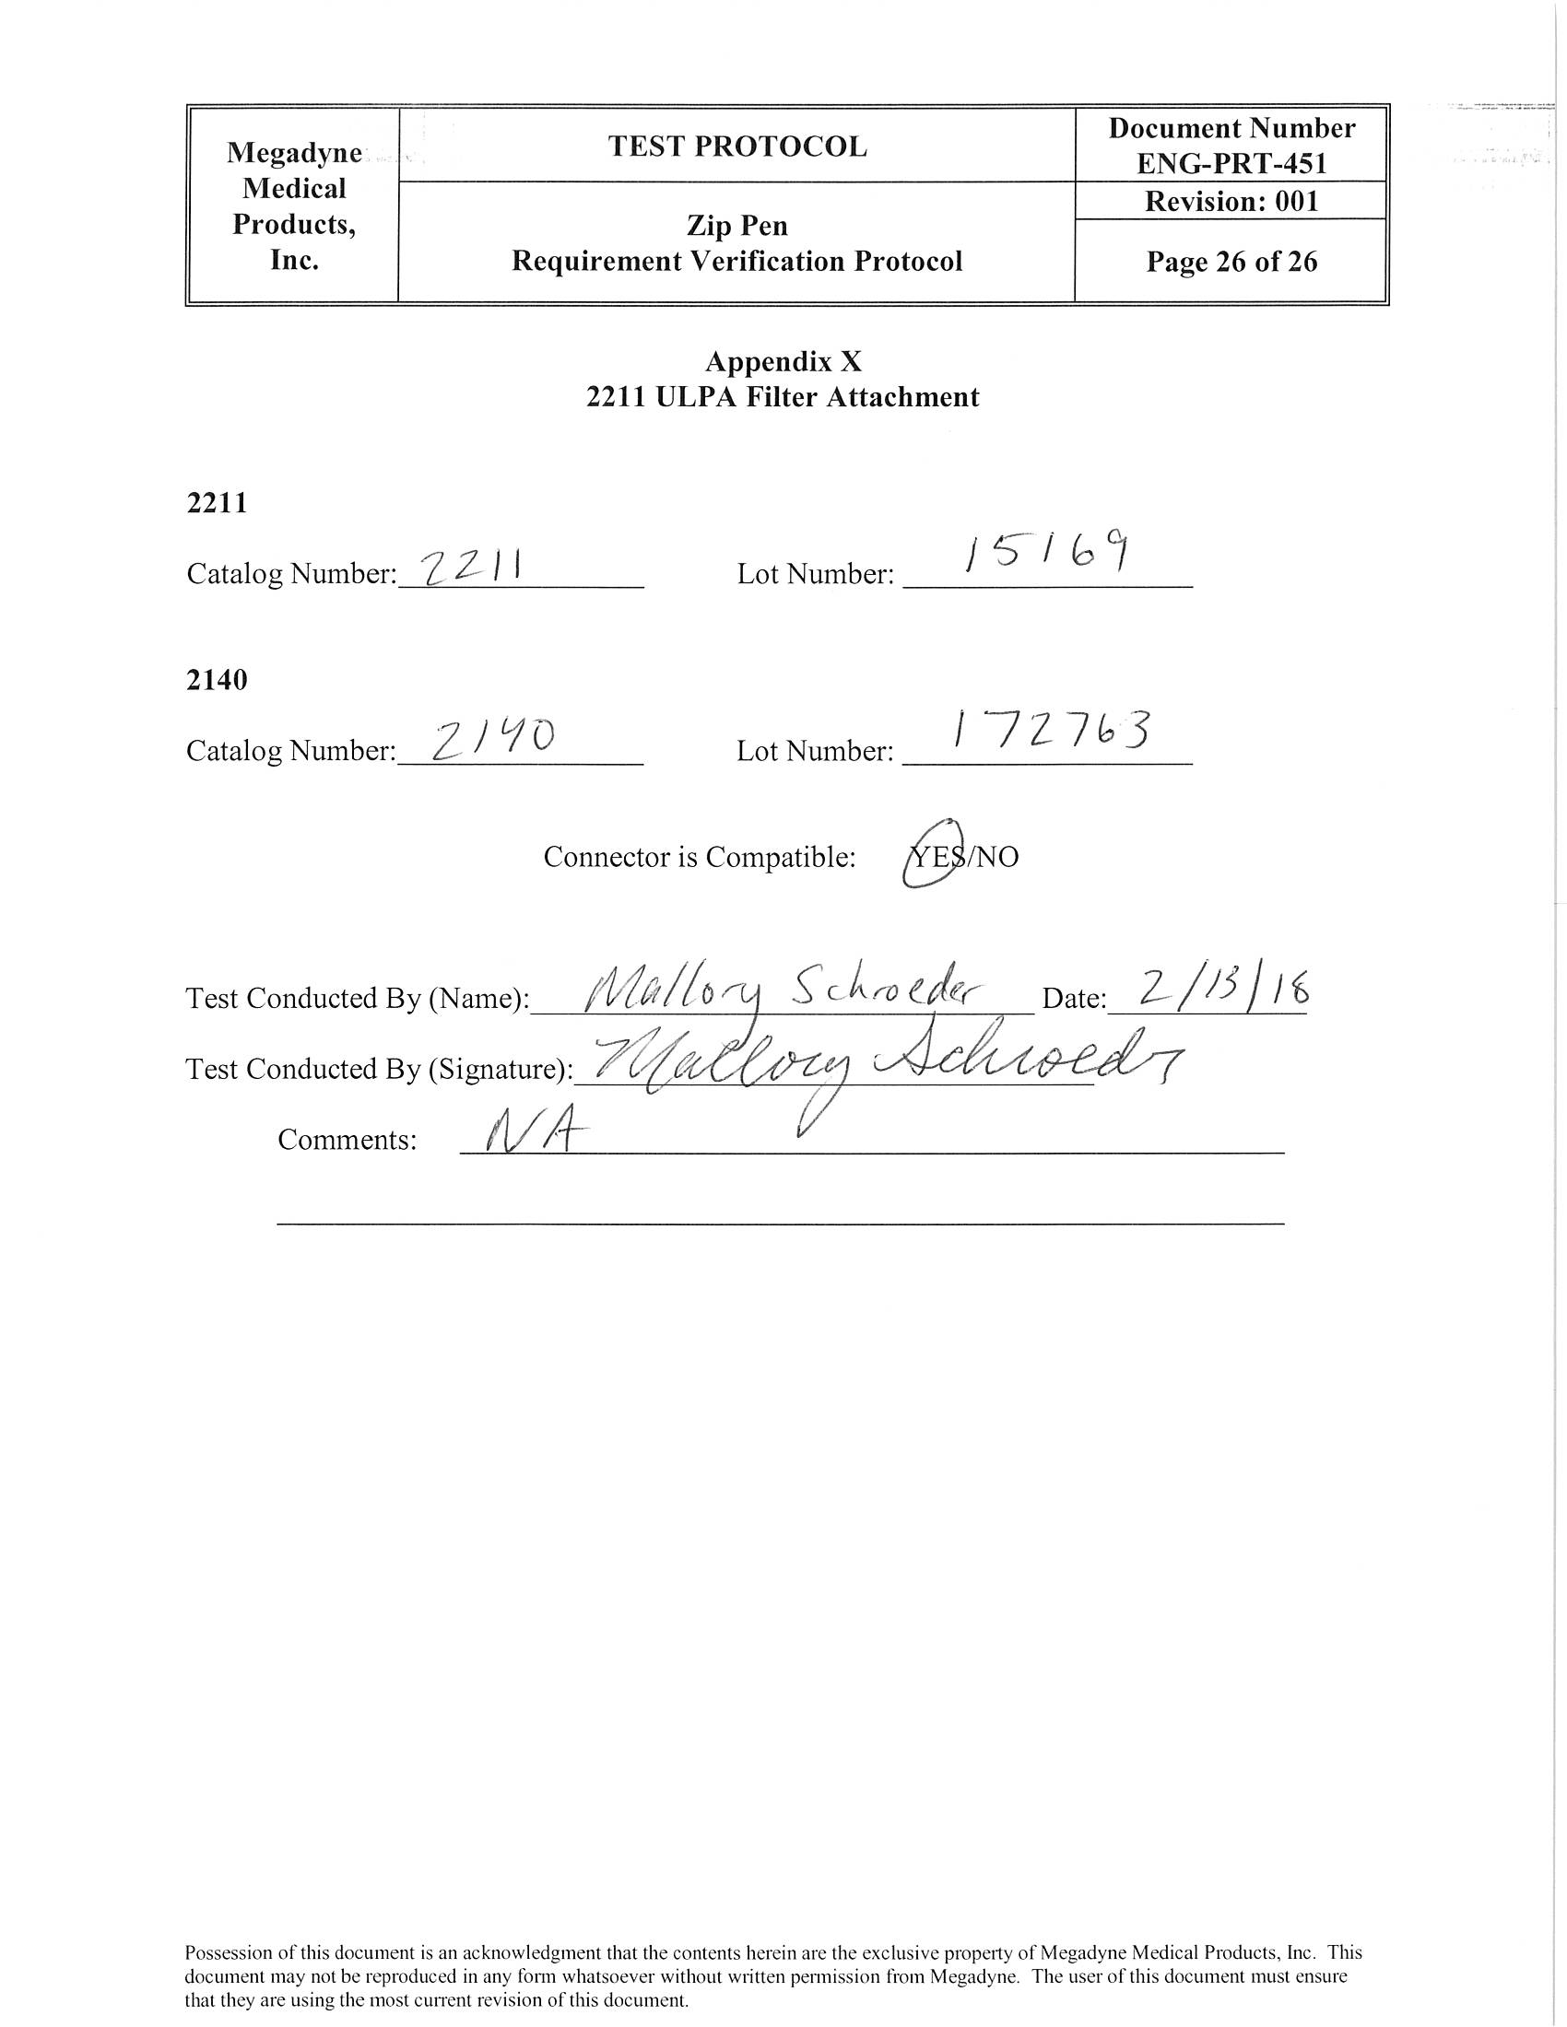

APPENDIX XI. EC Connector Instron Pull Test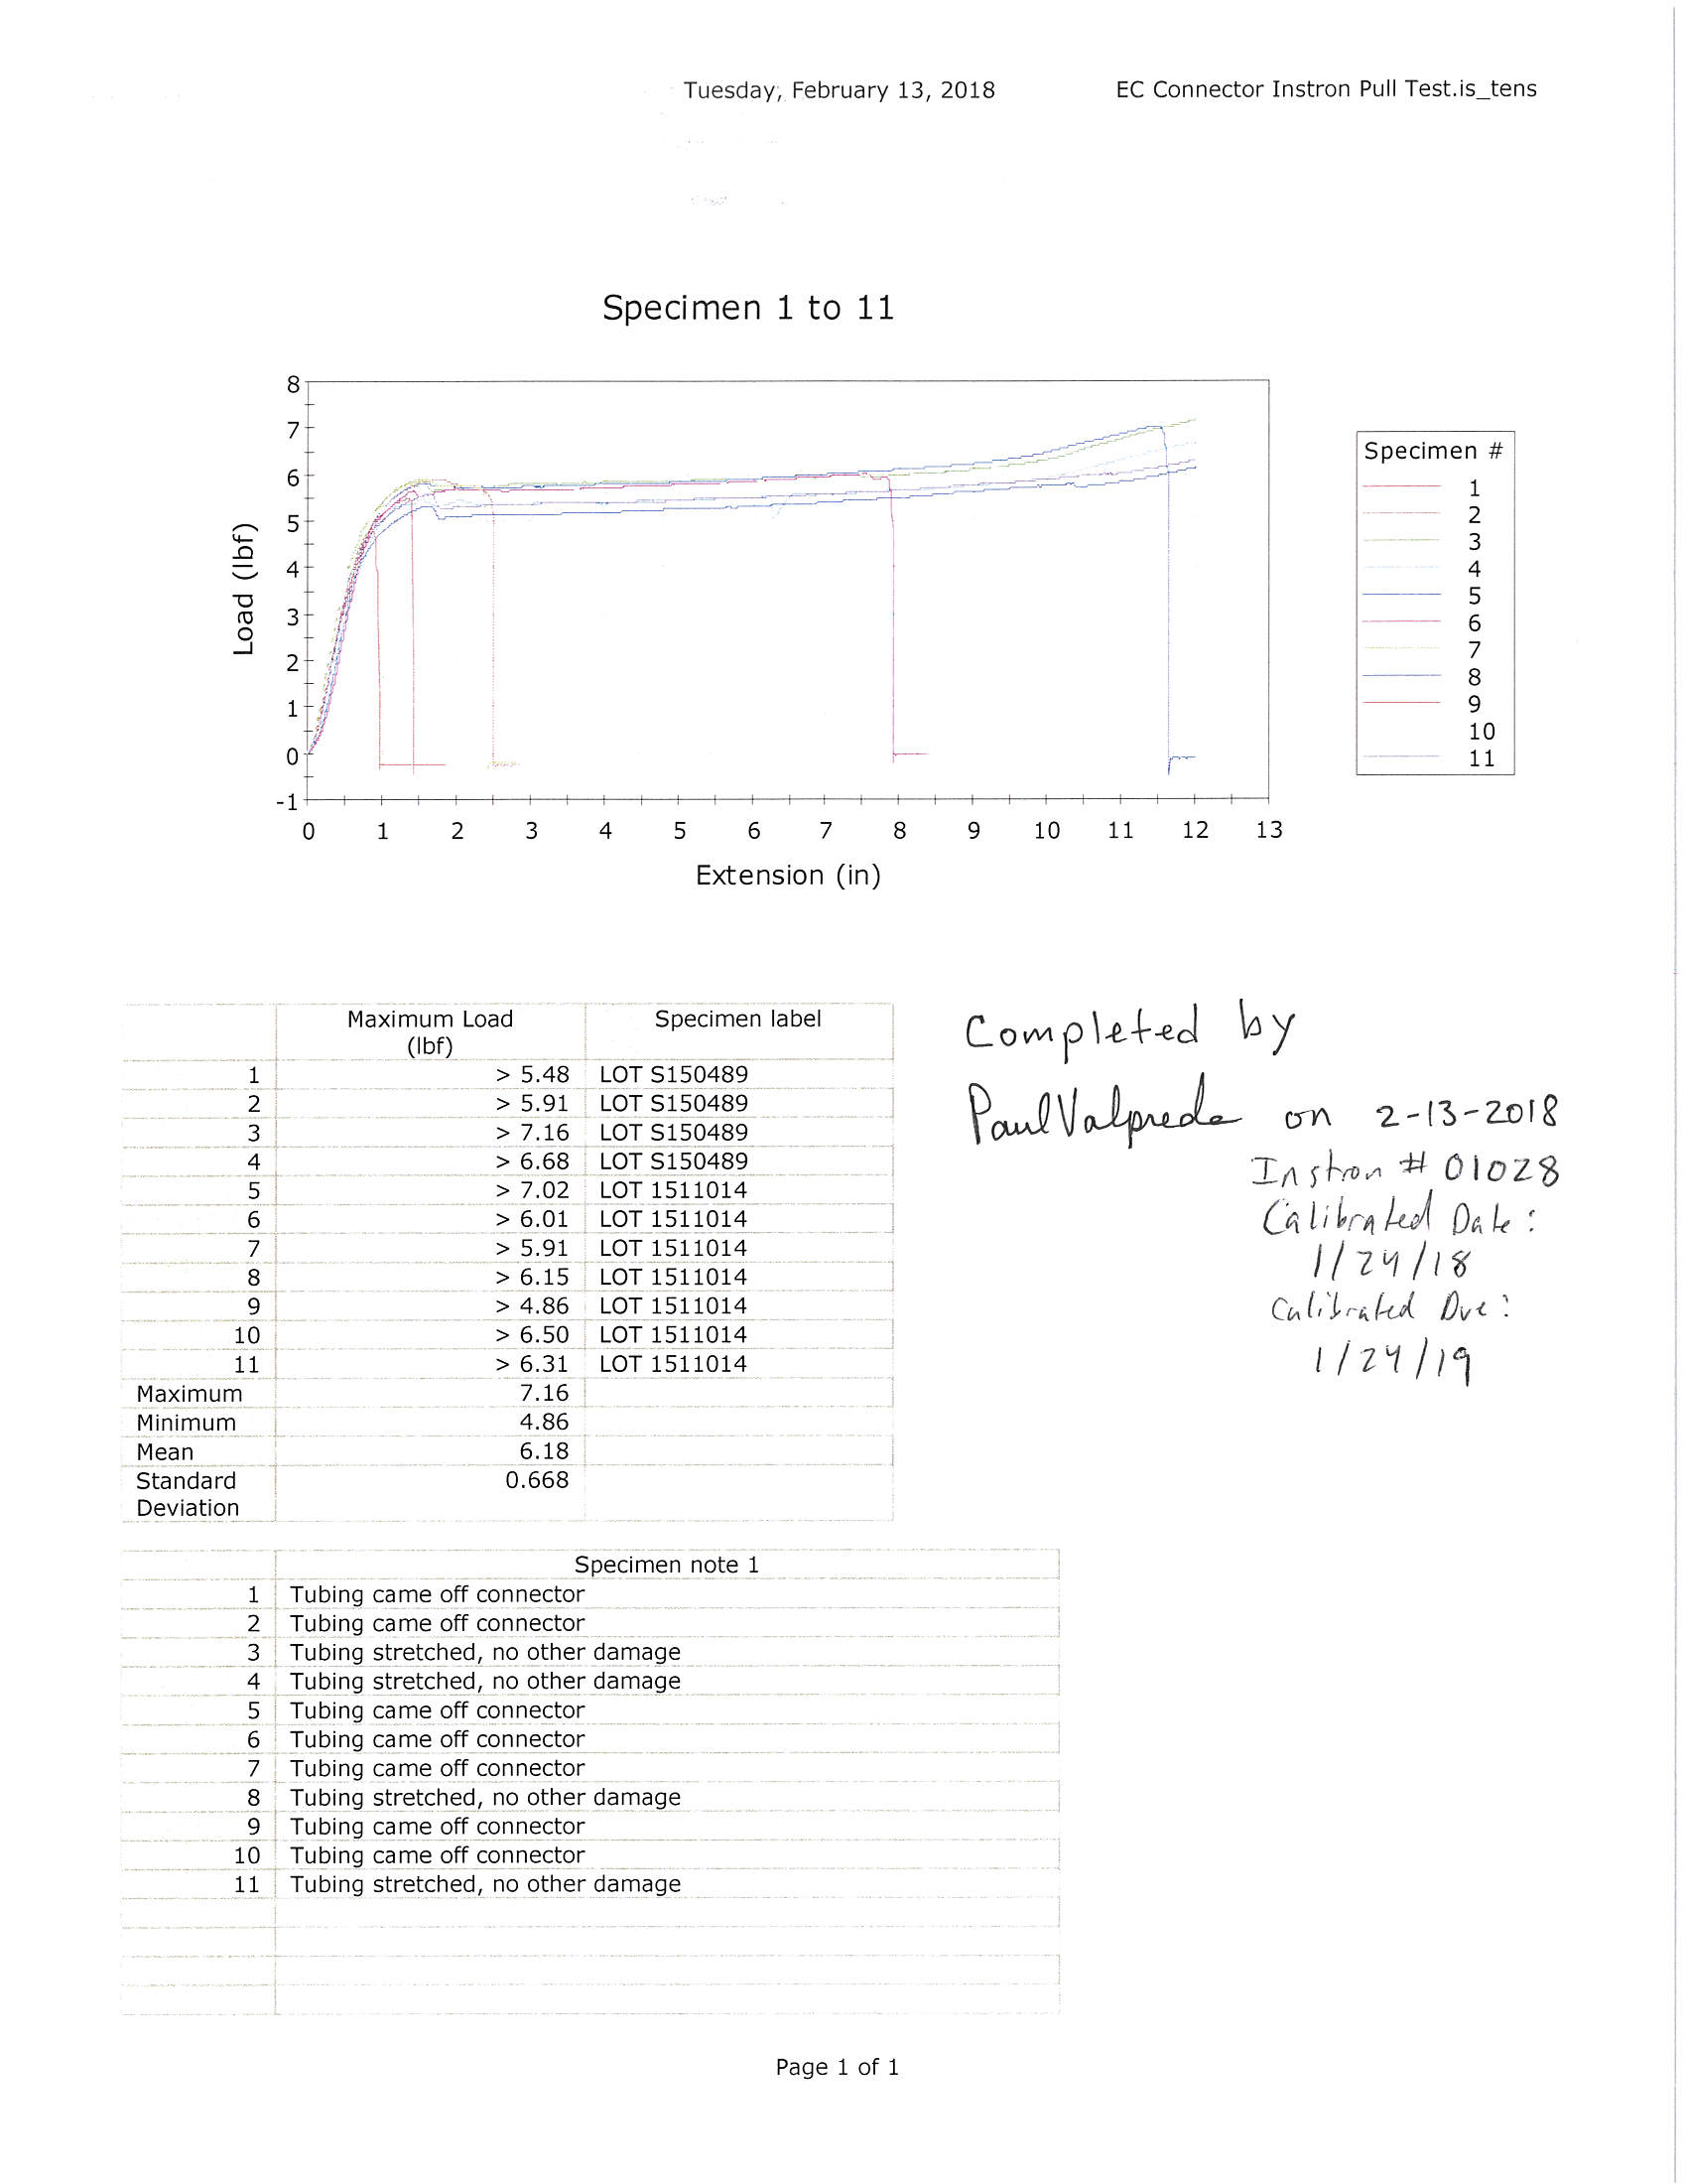

APPENDIX XII. Cable Cytotoxicity 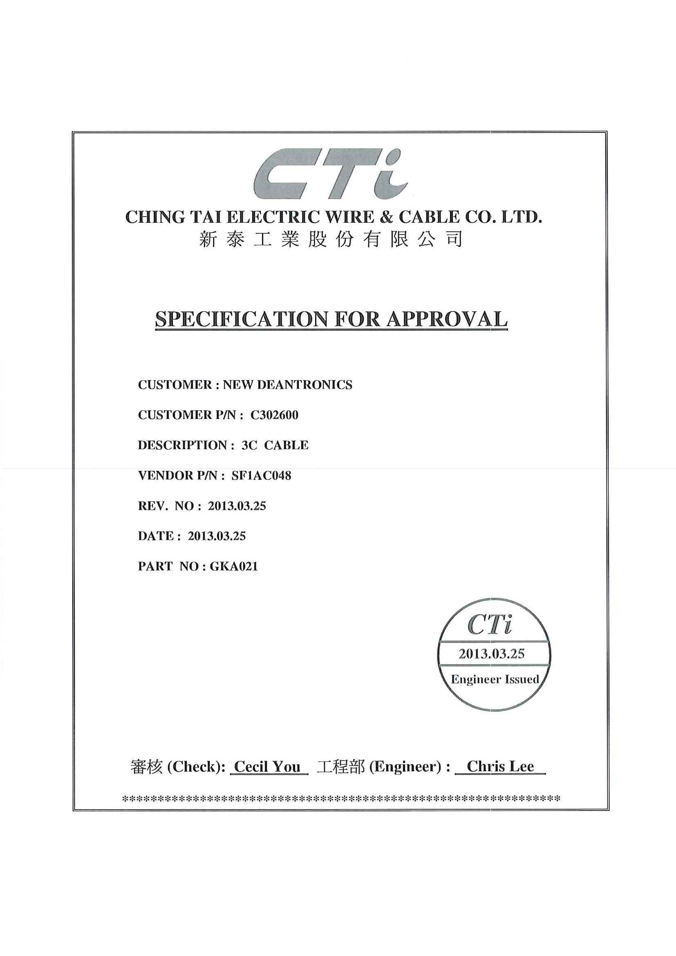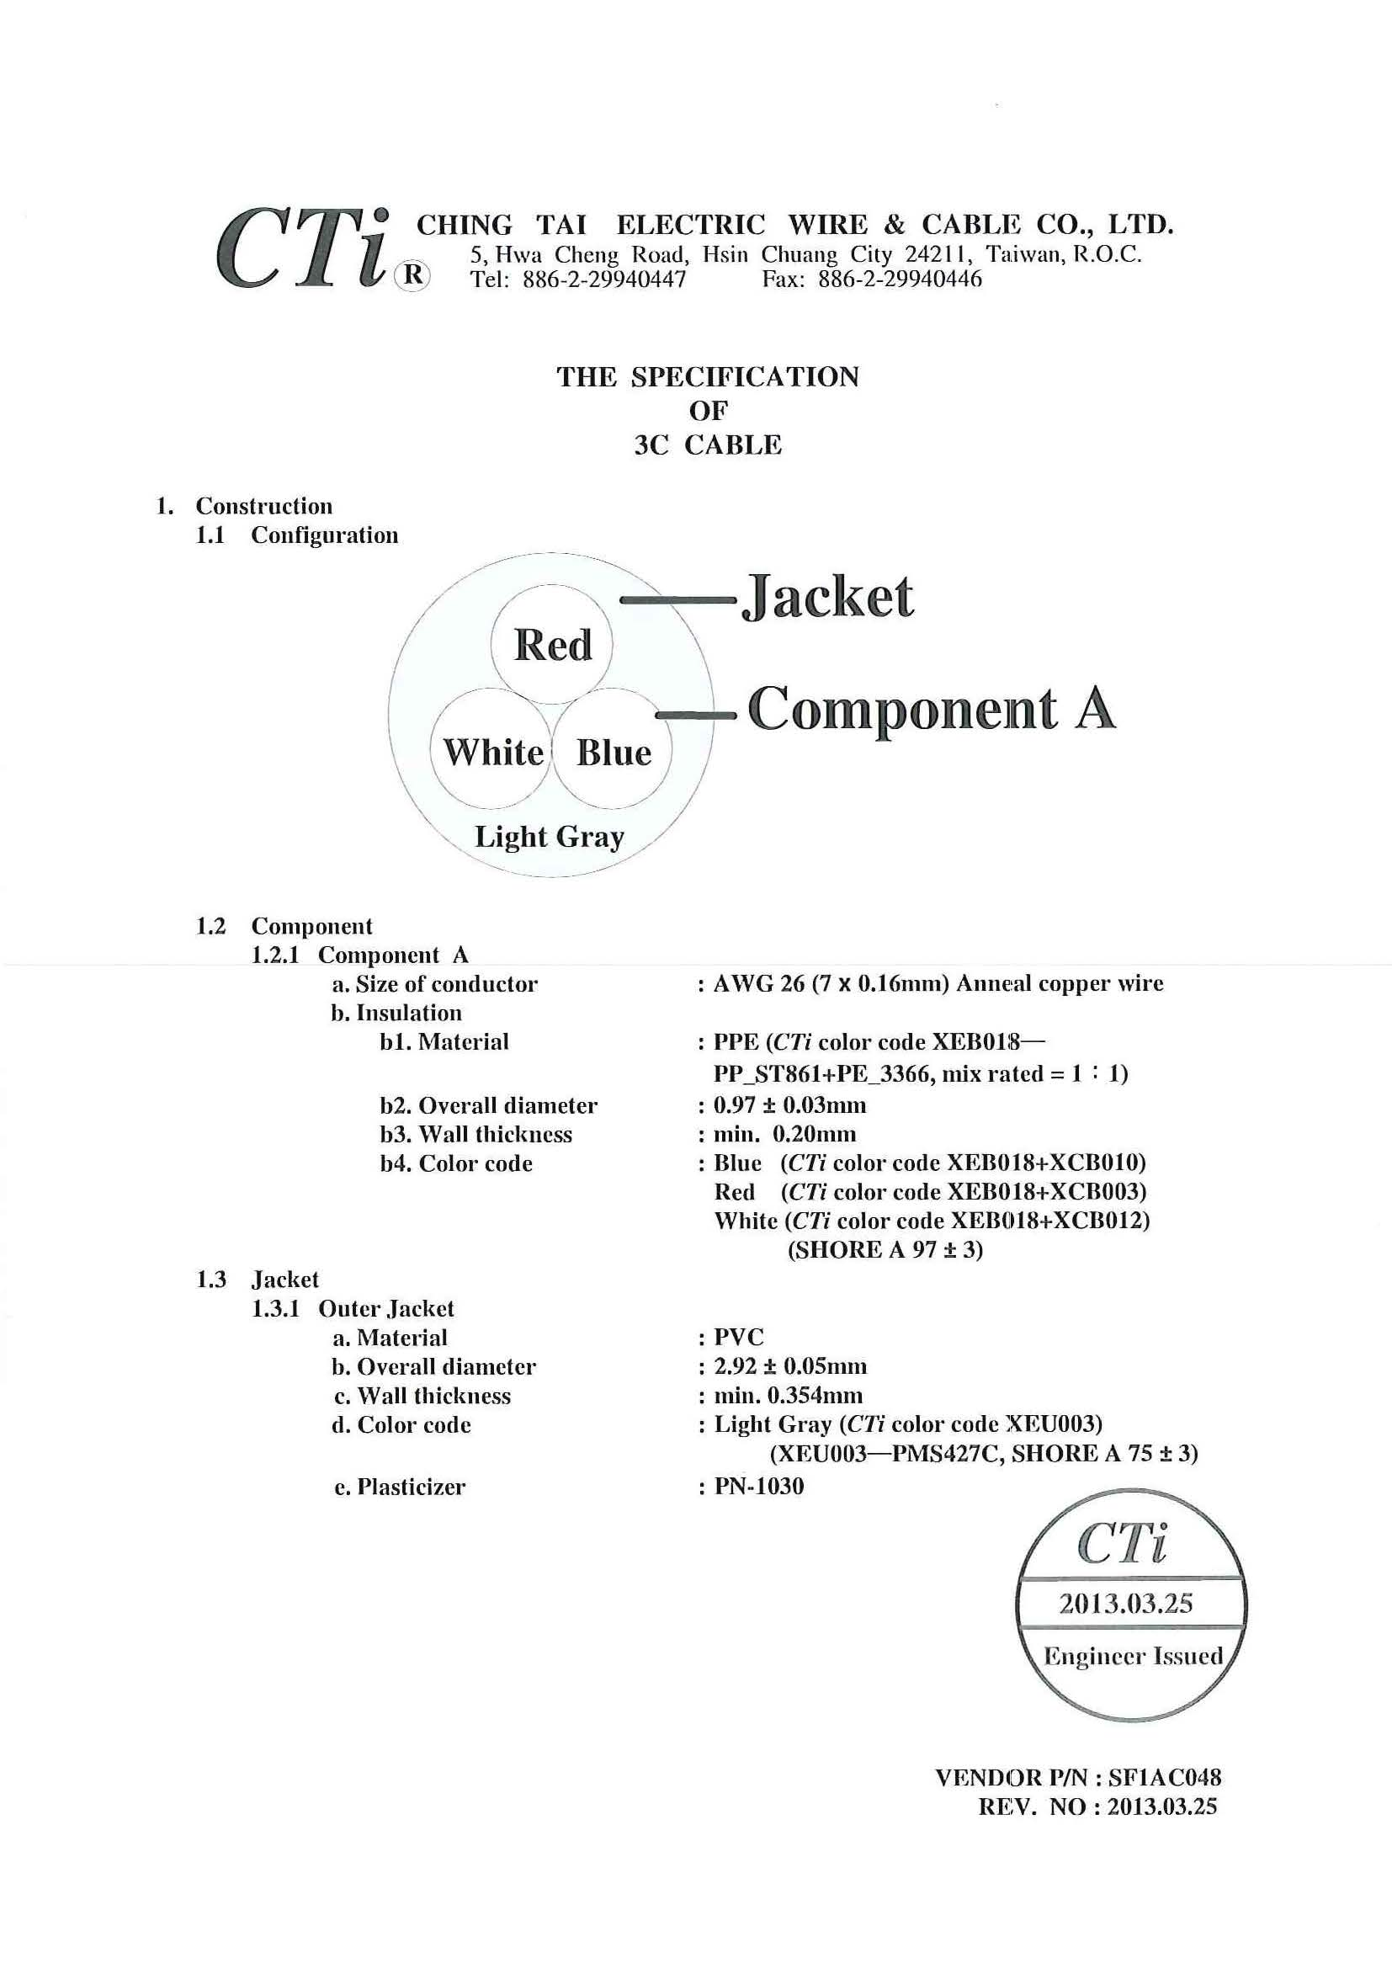

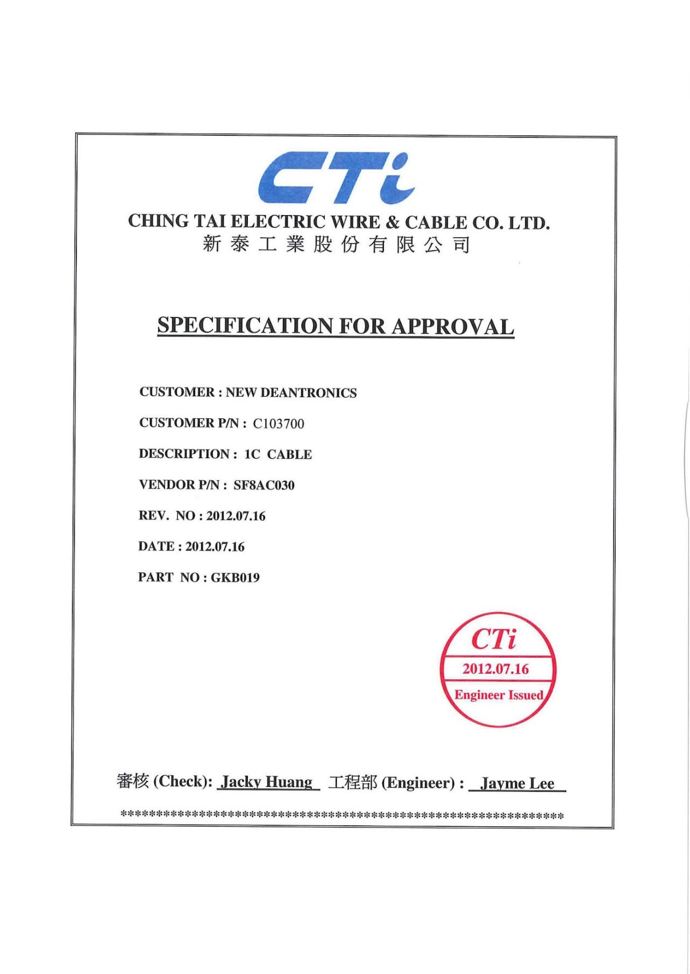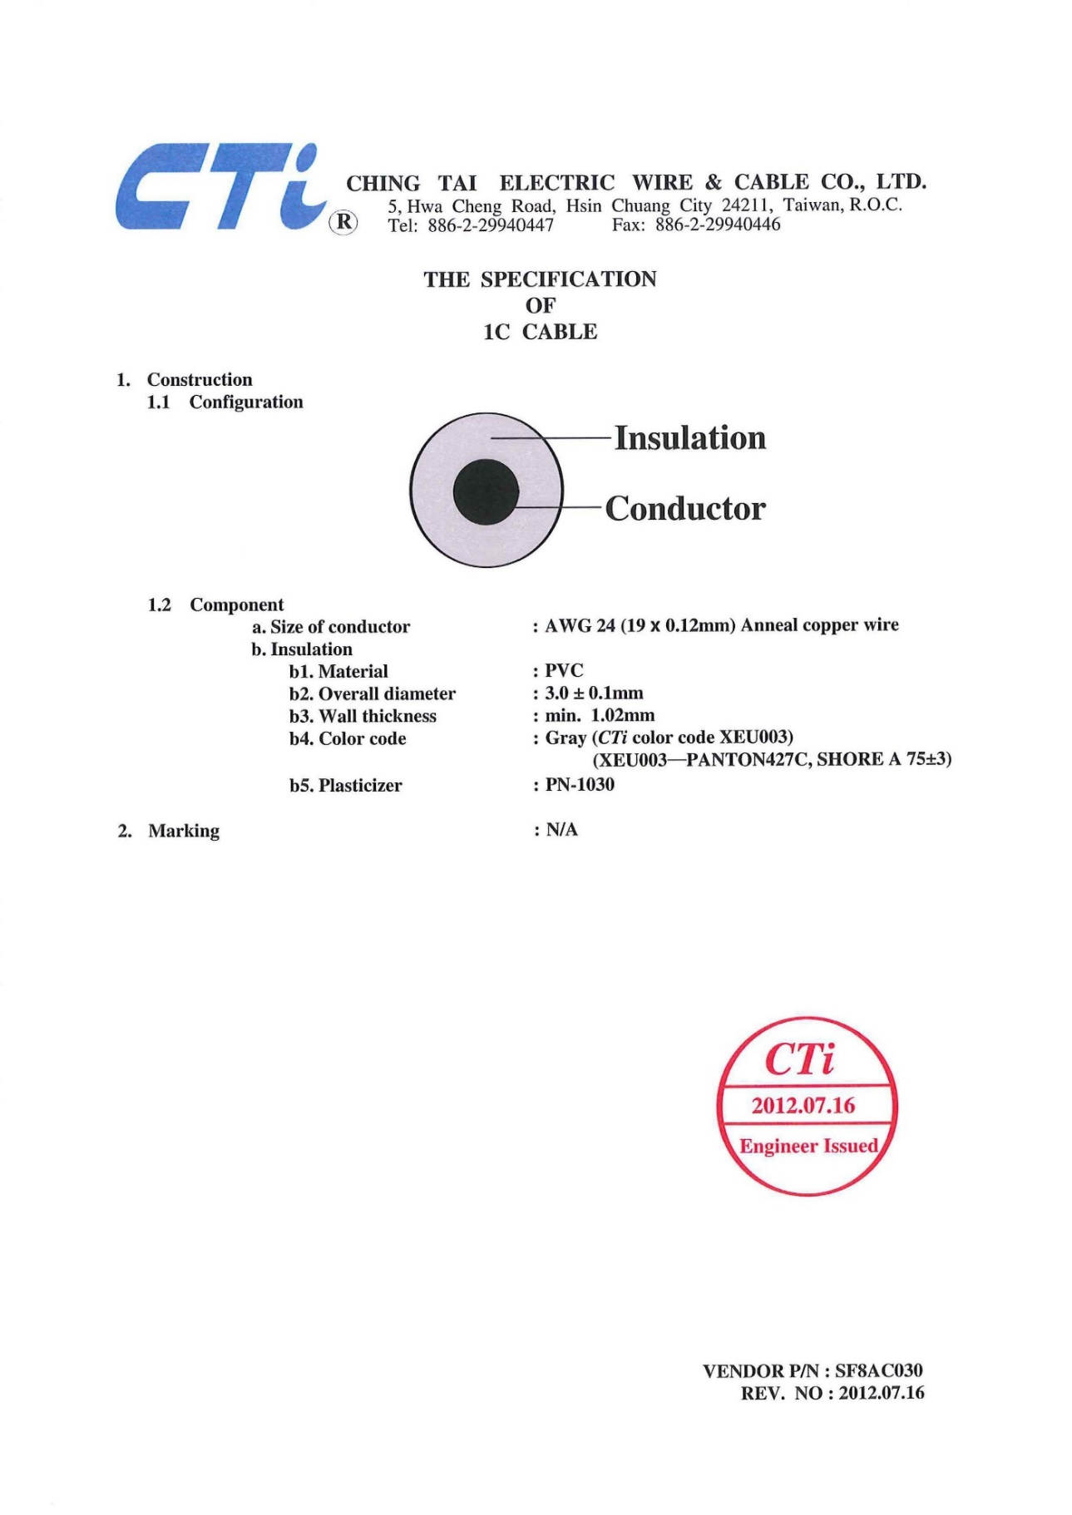

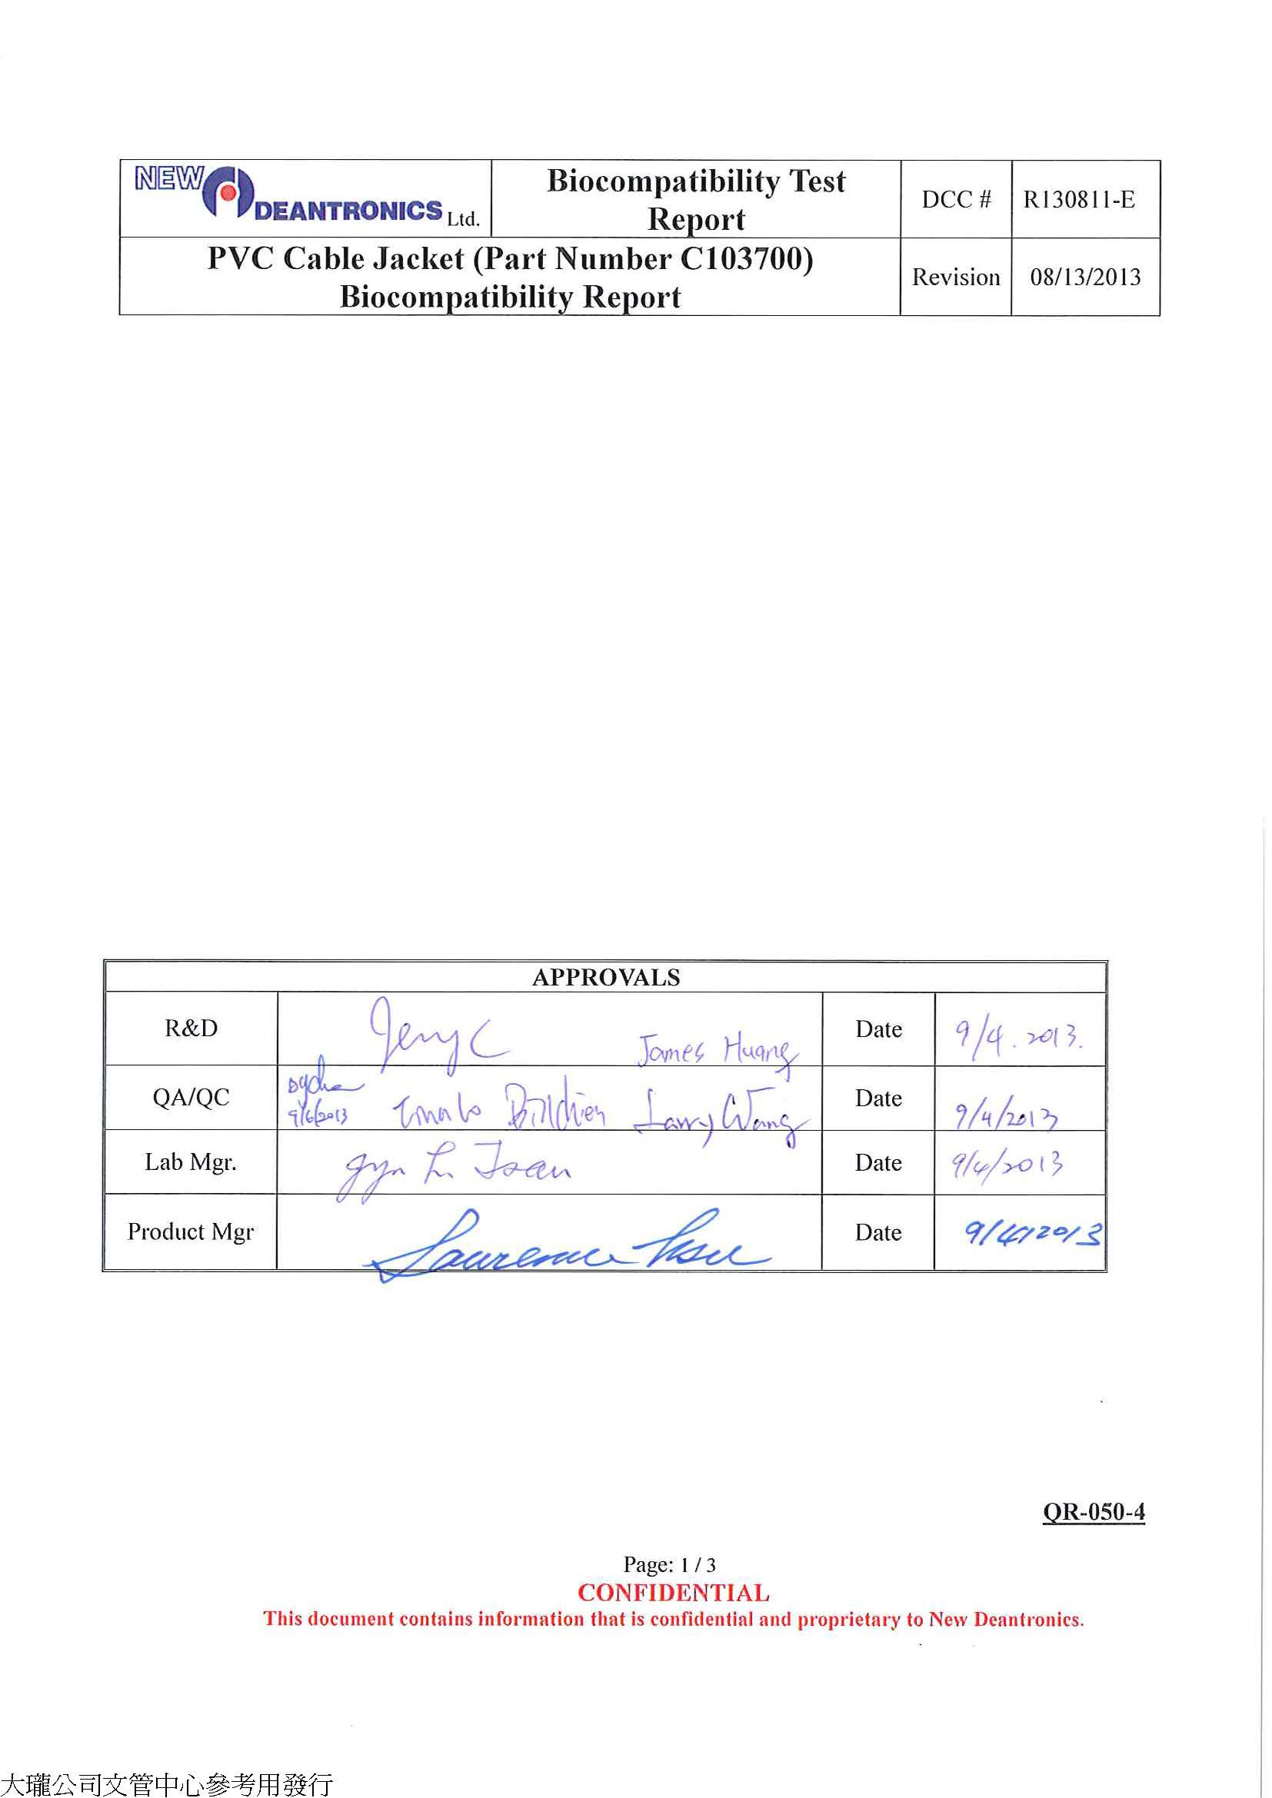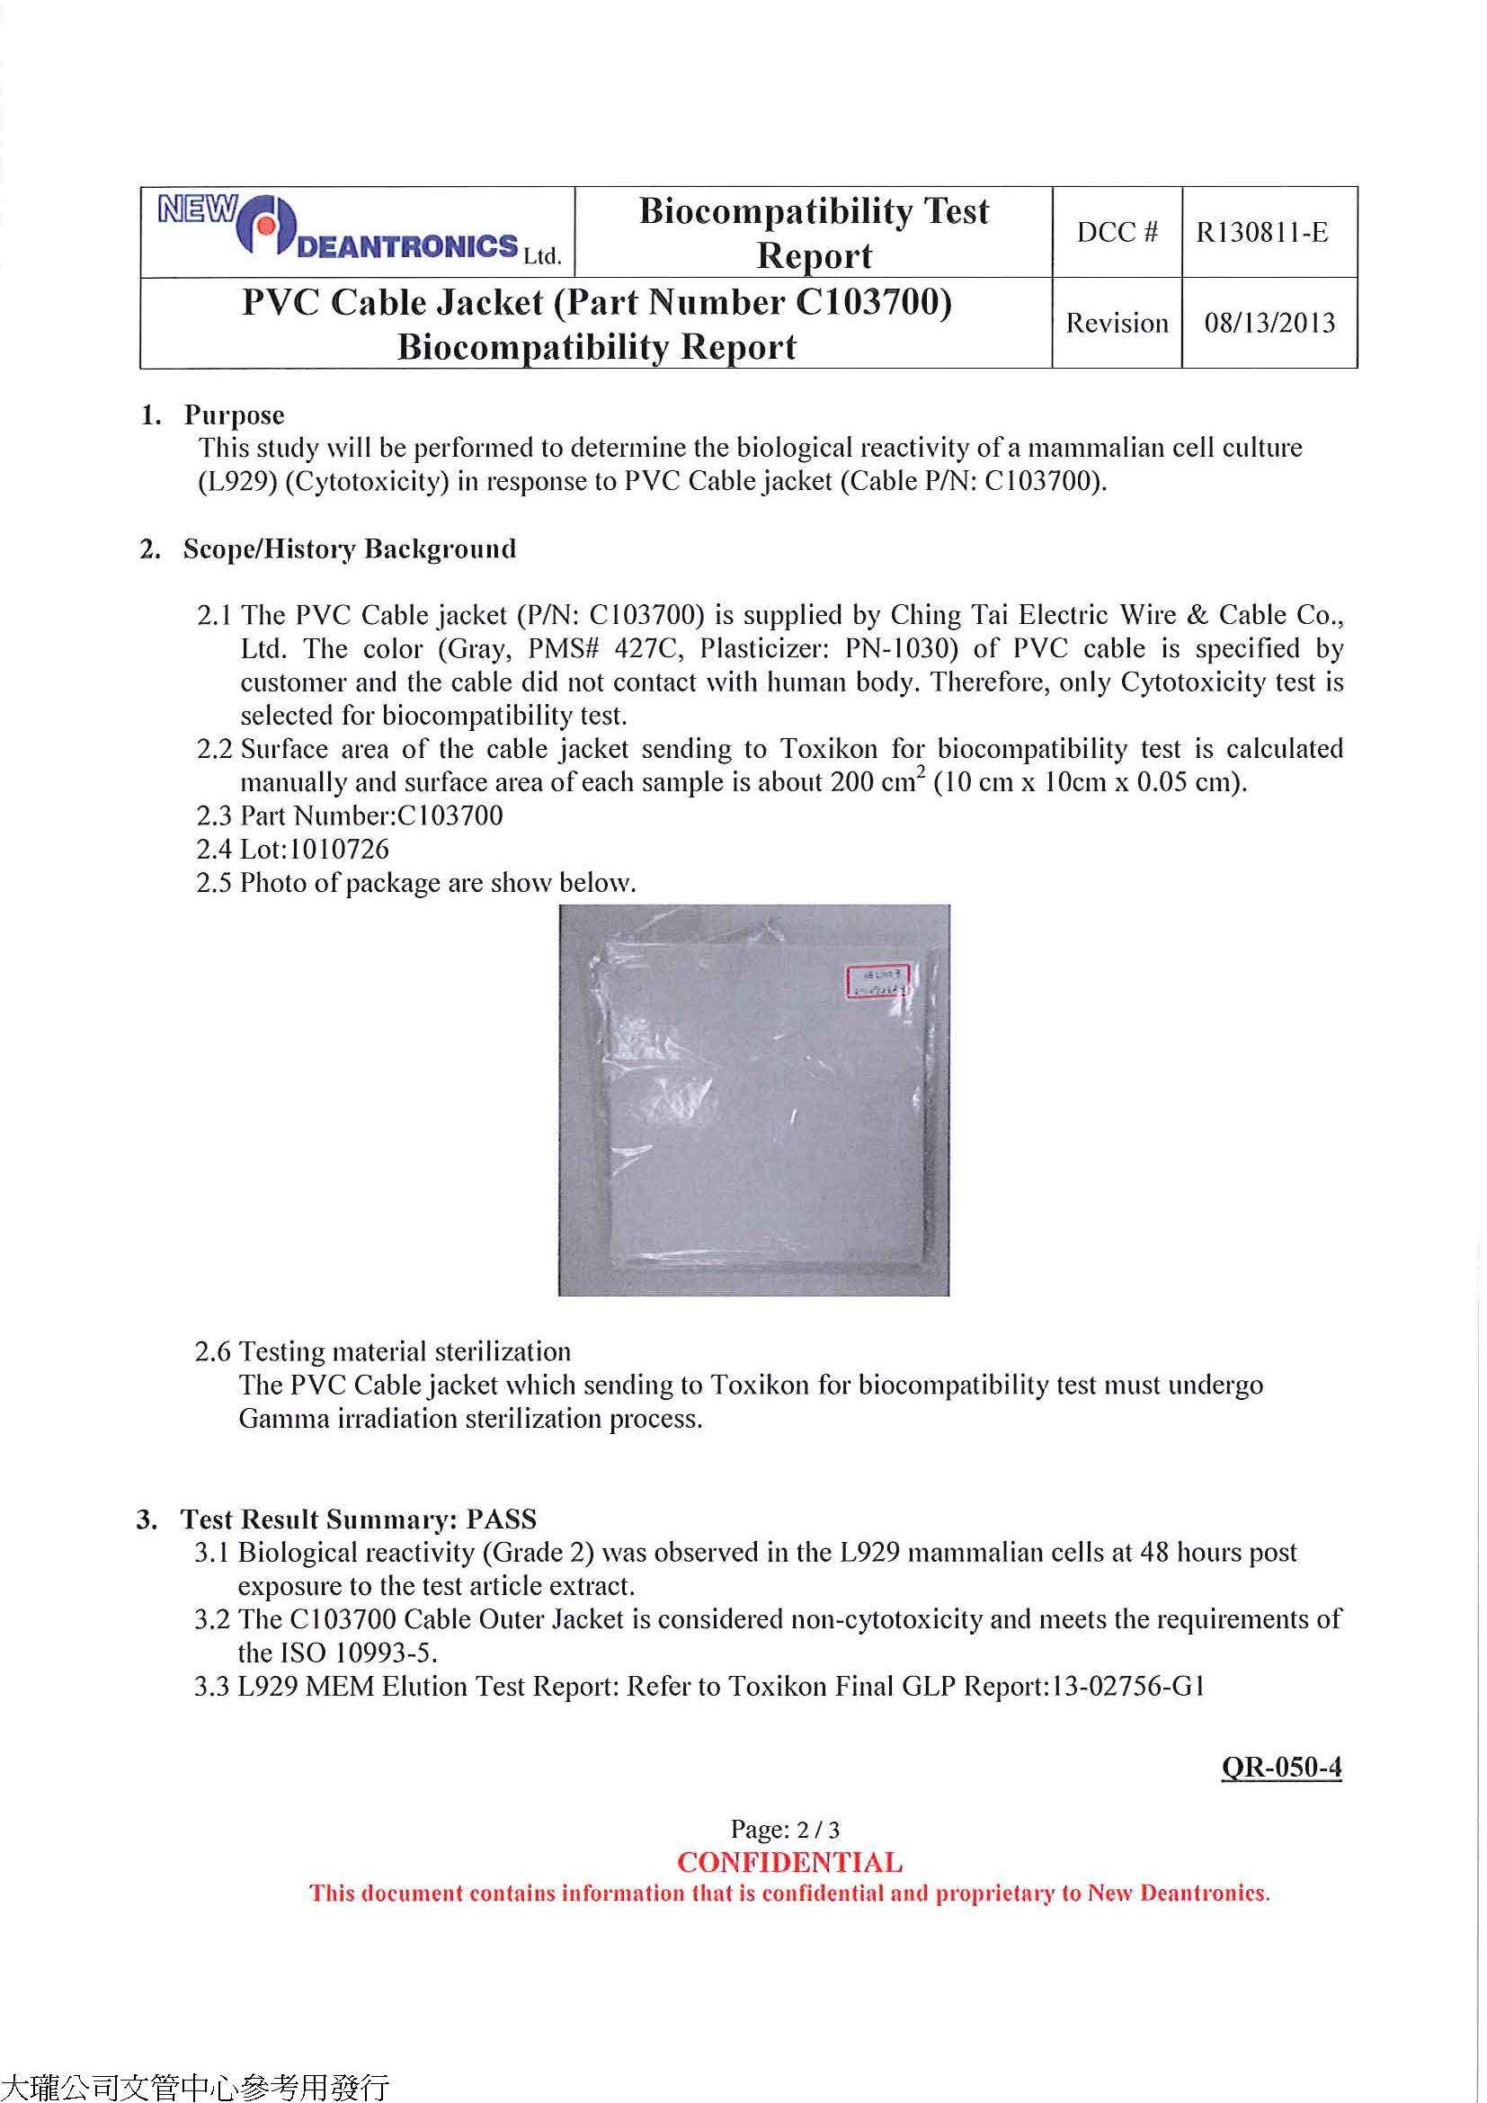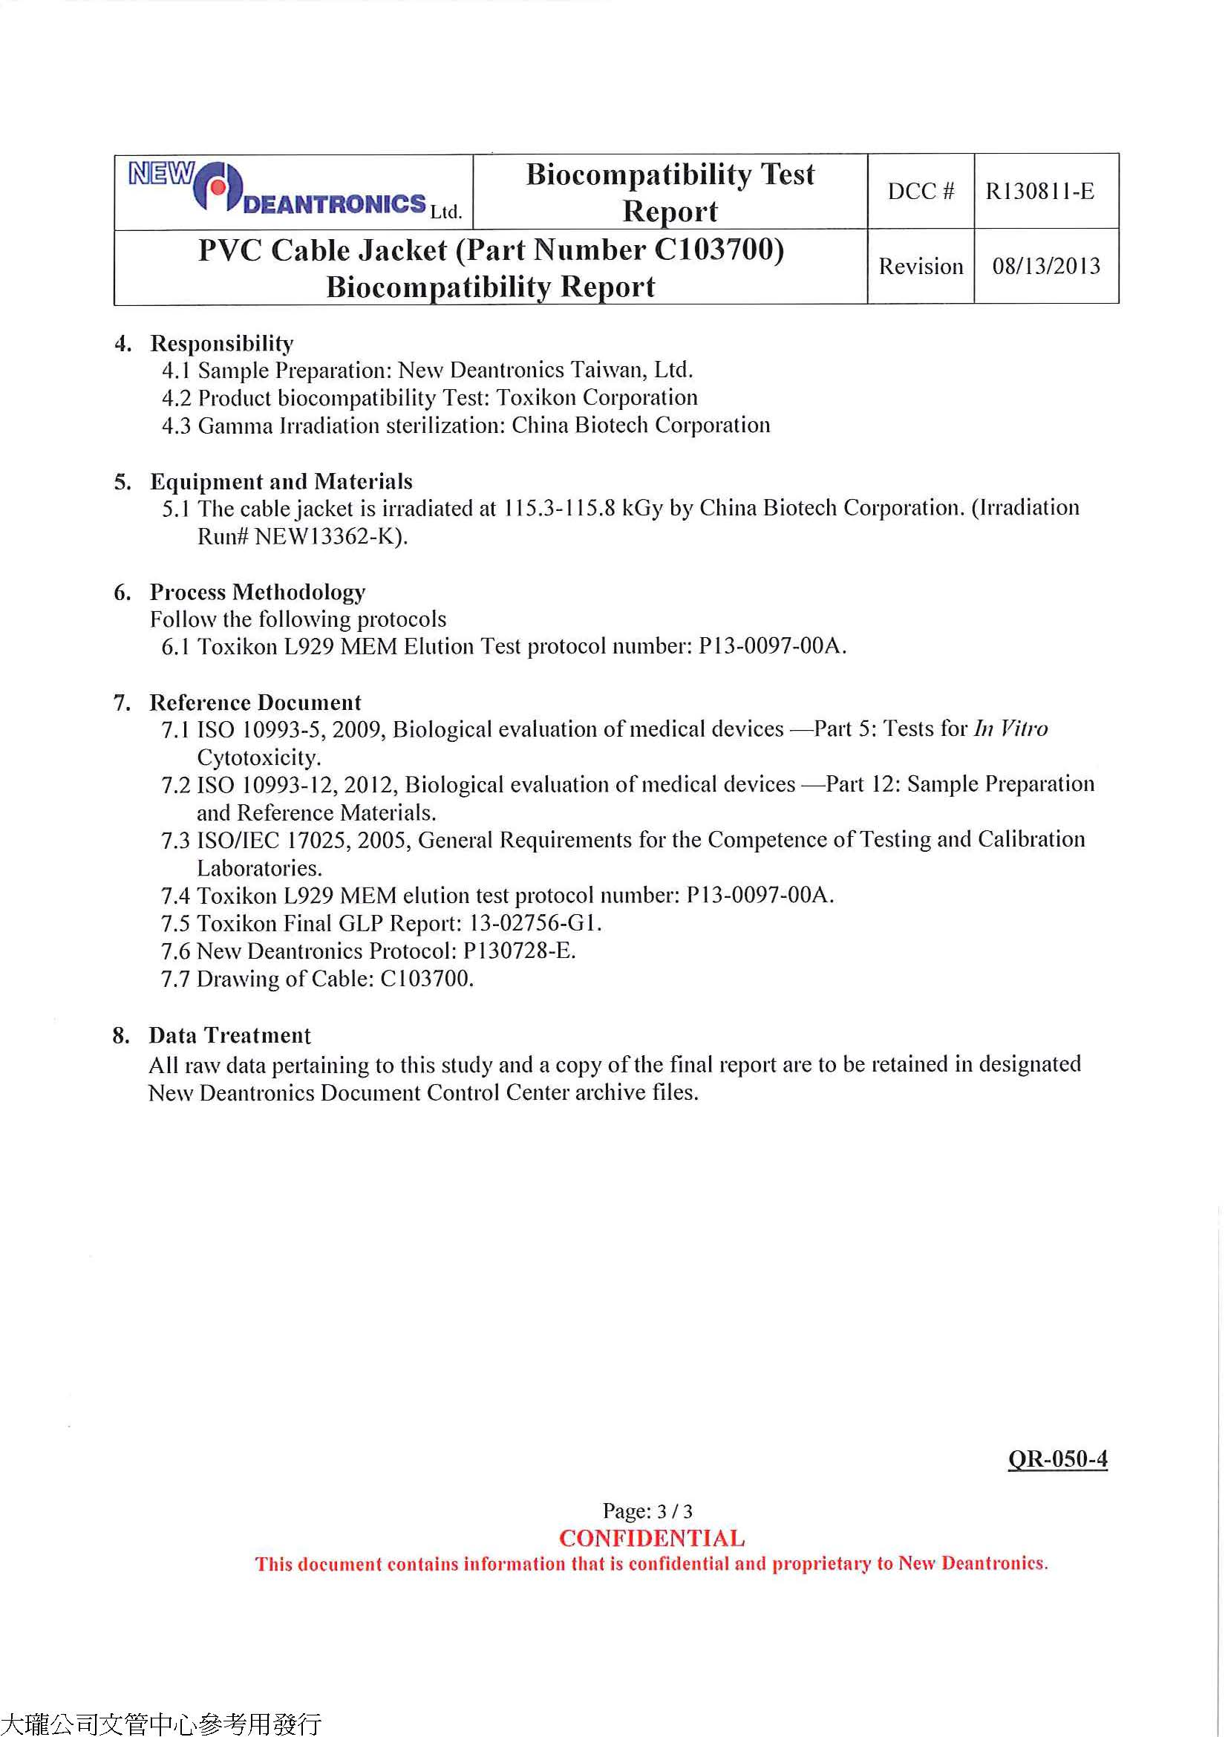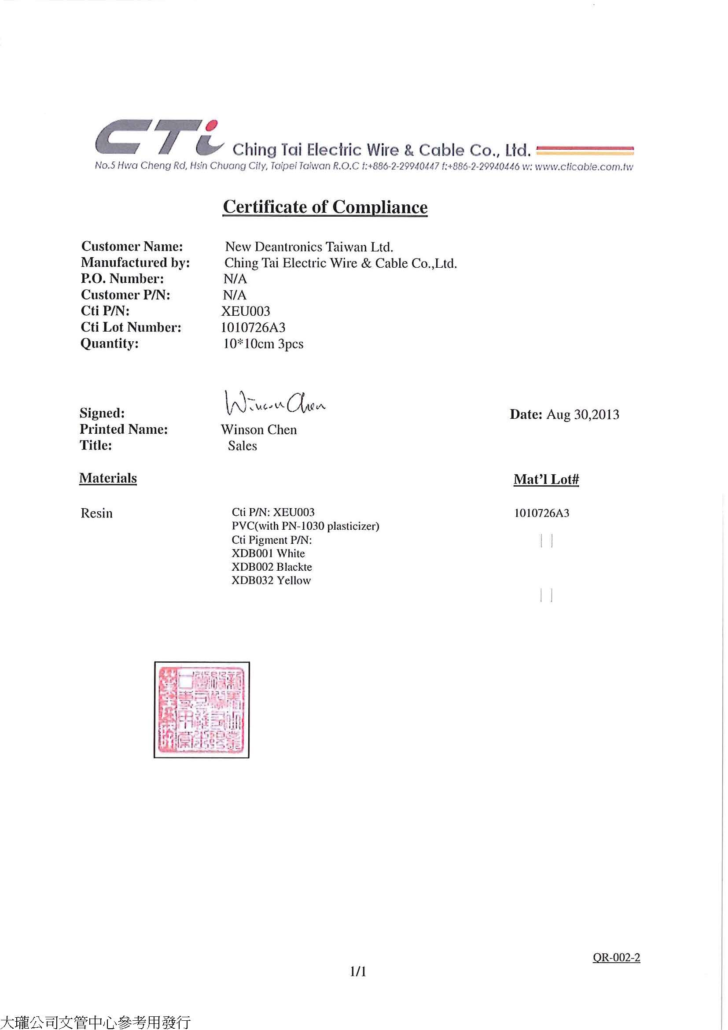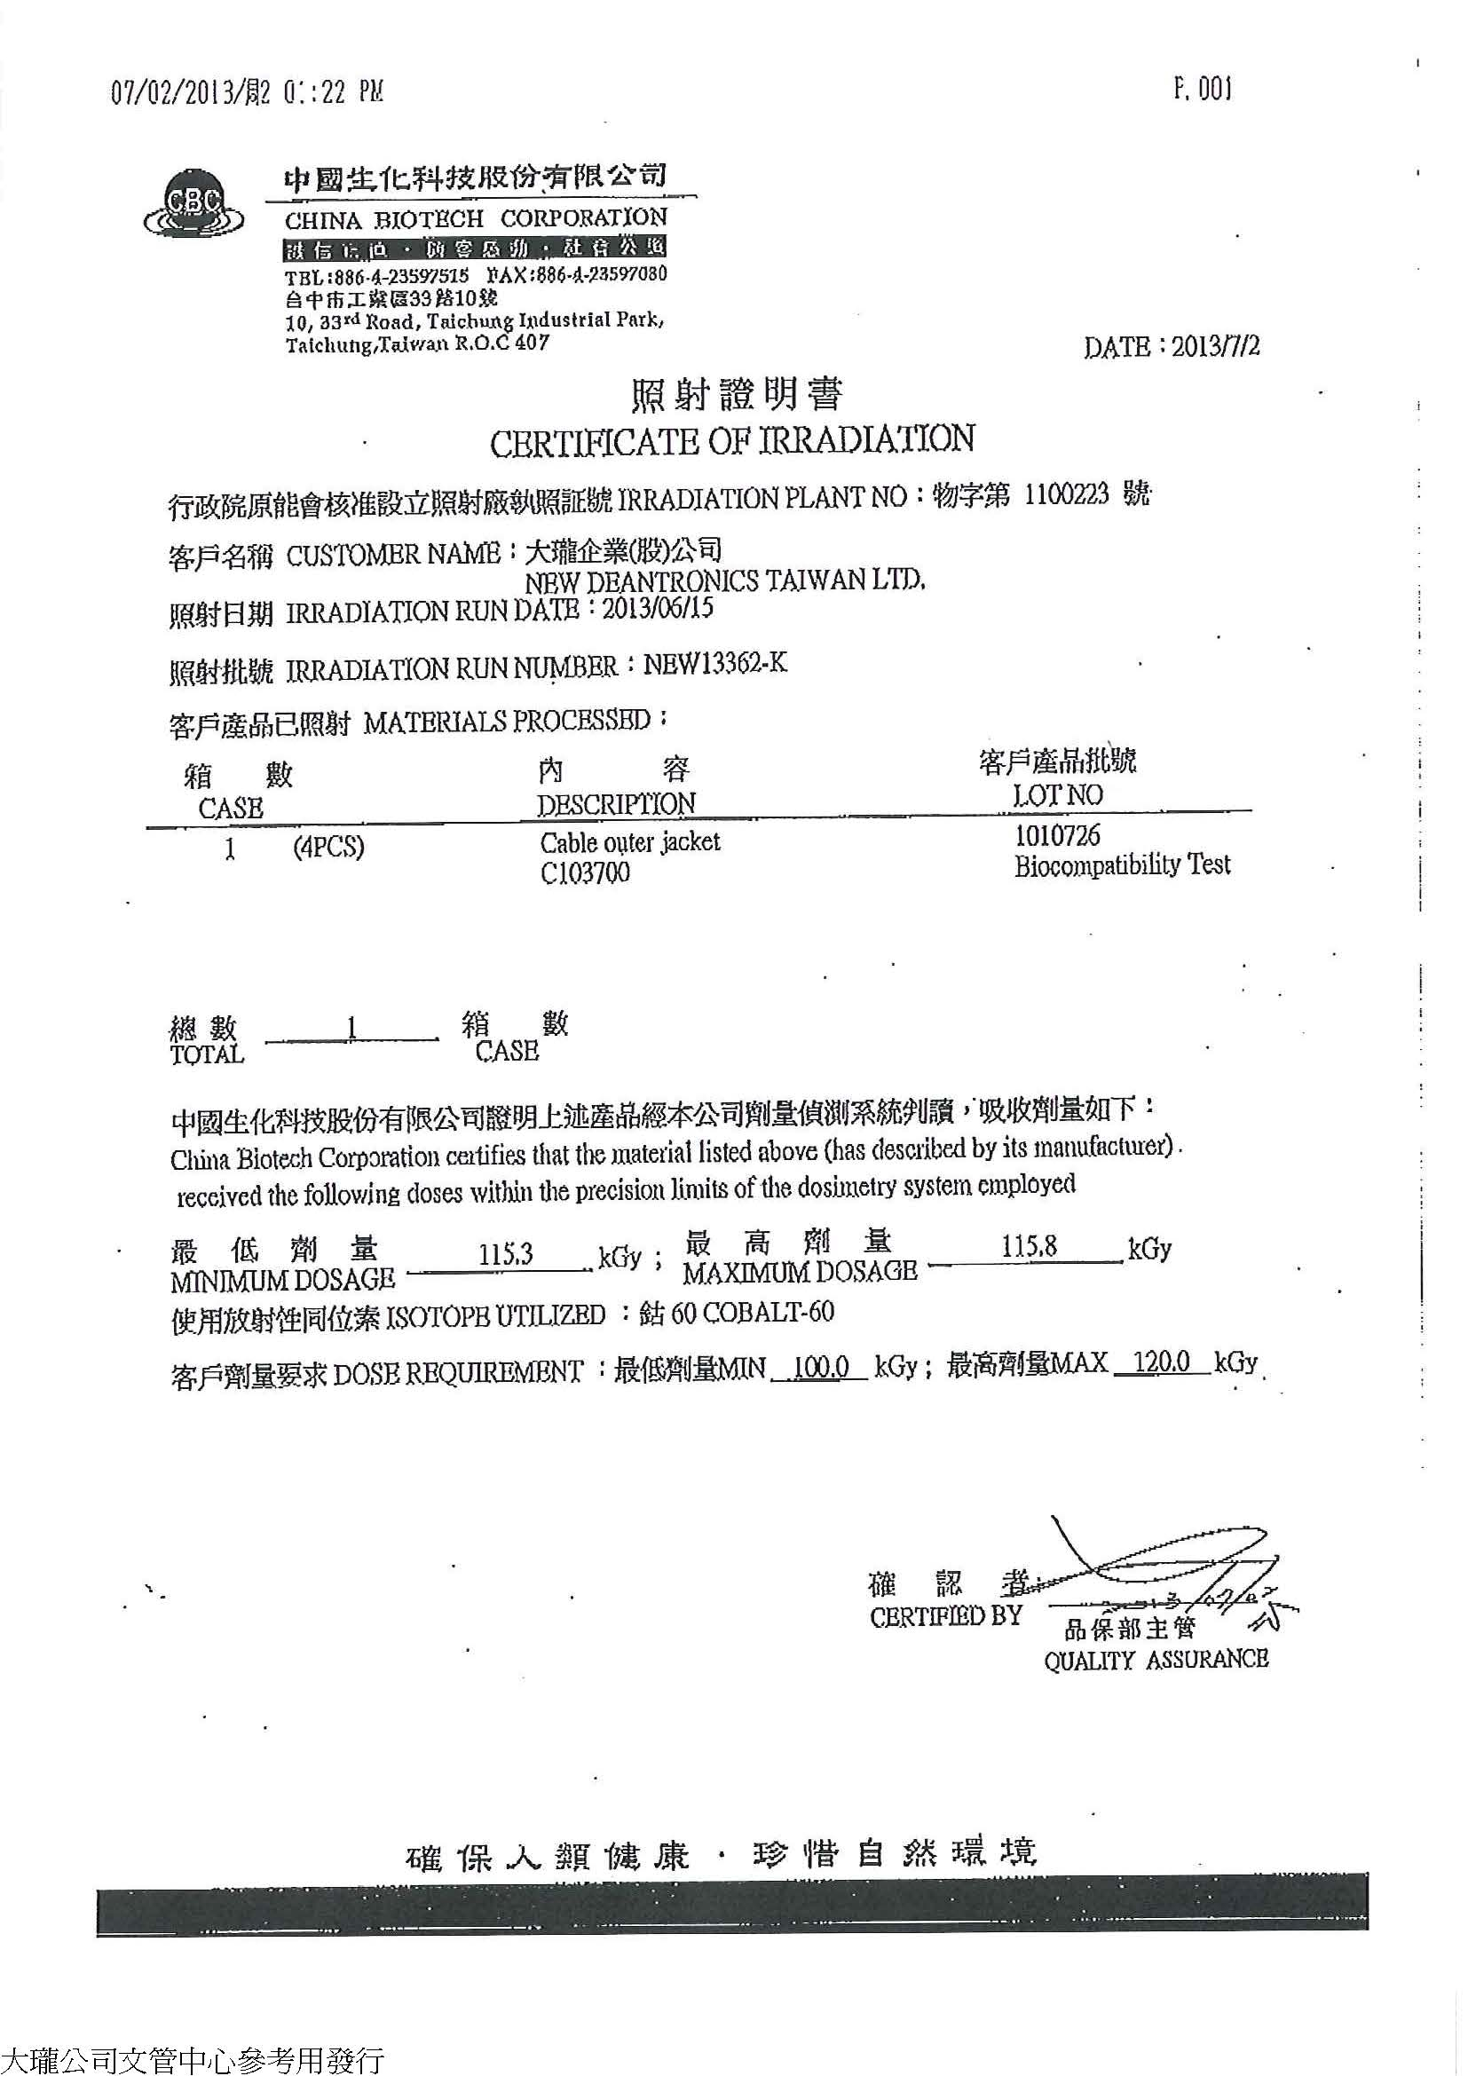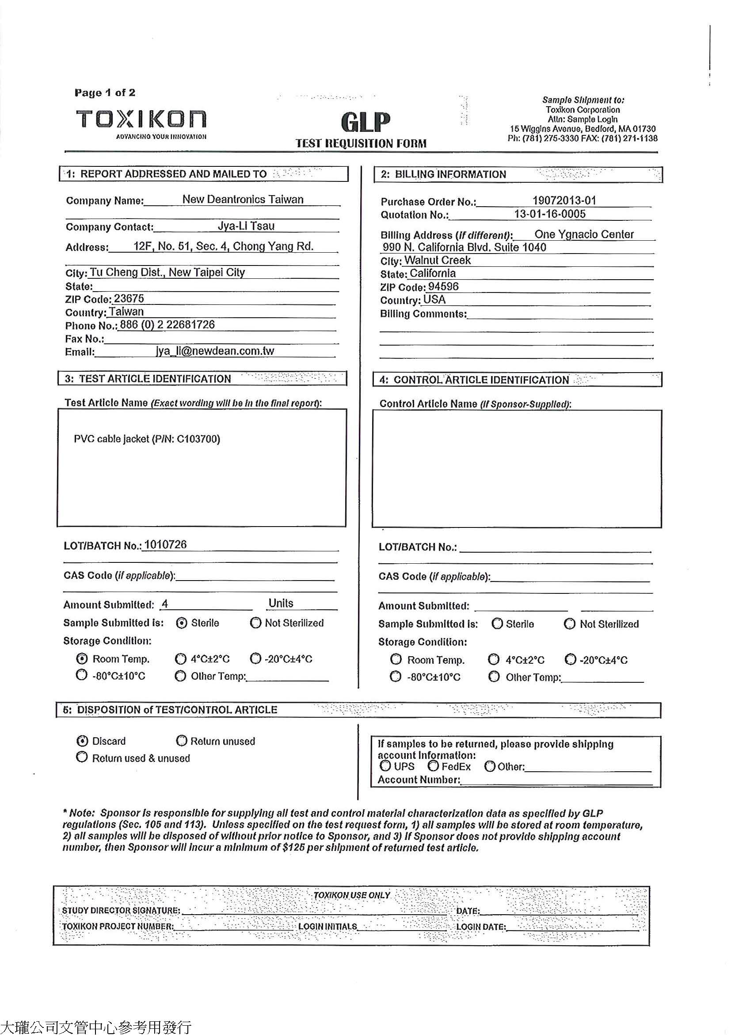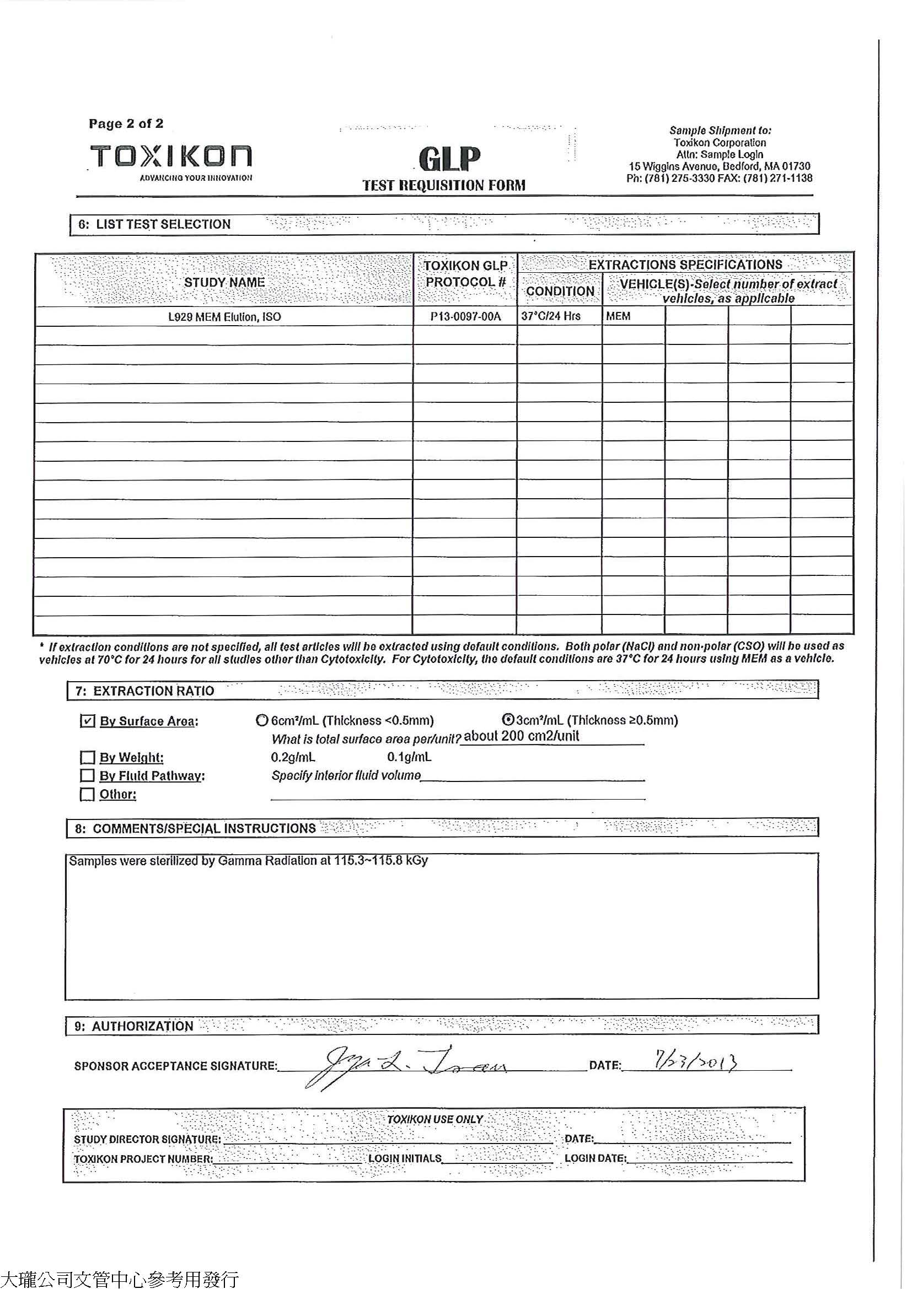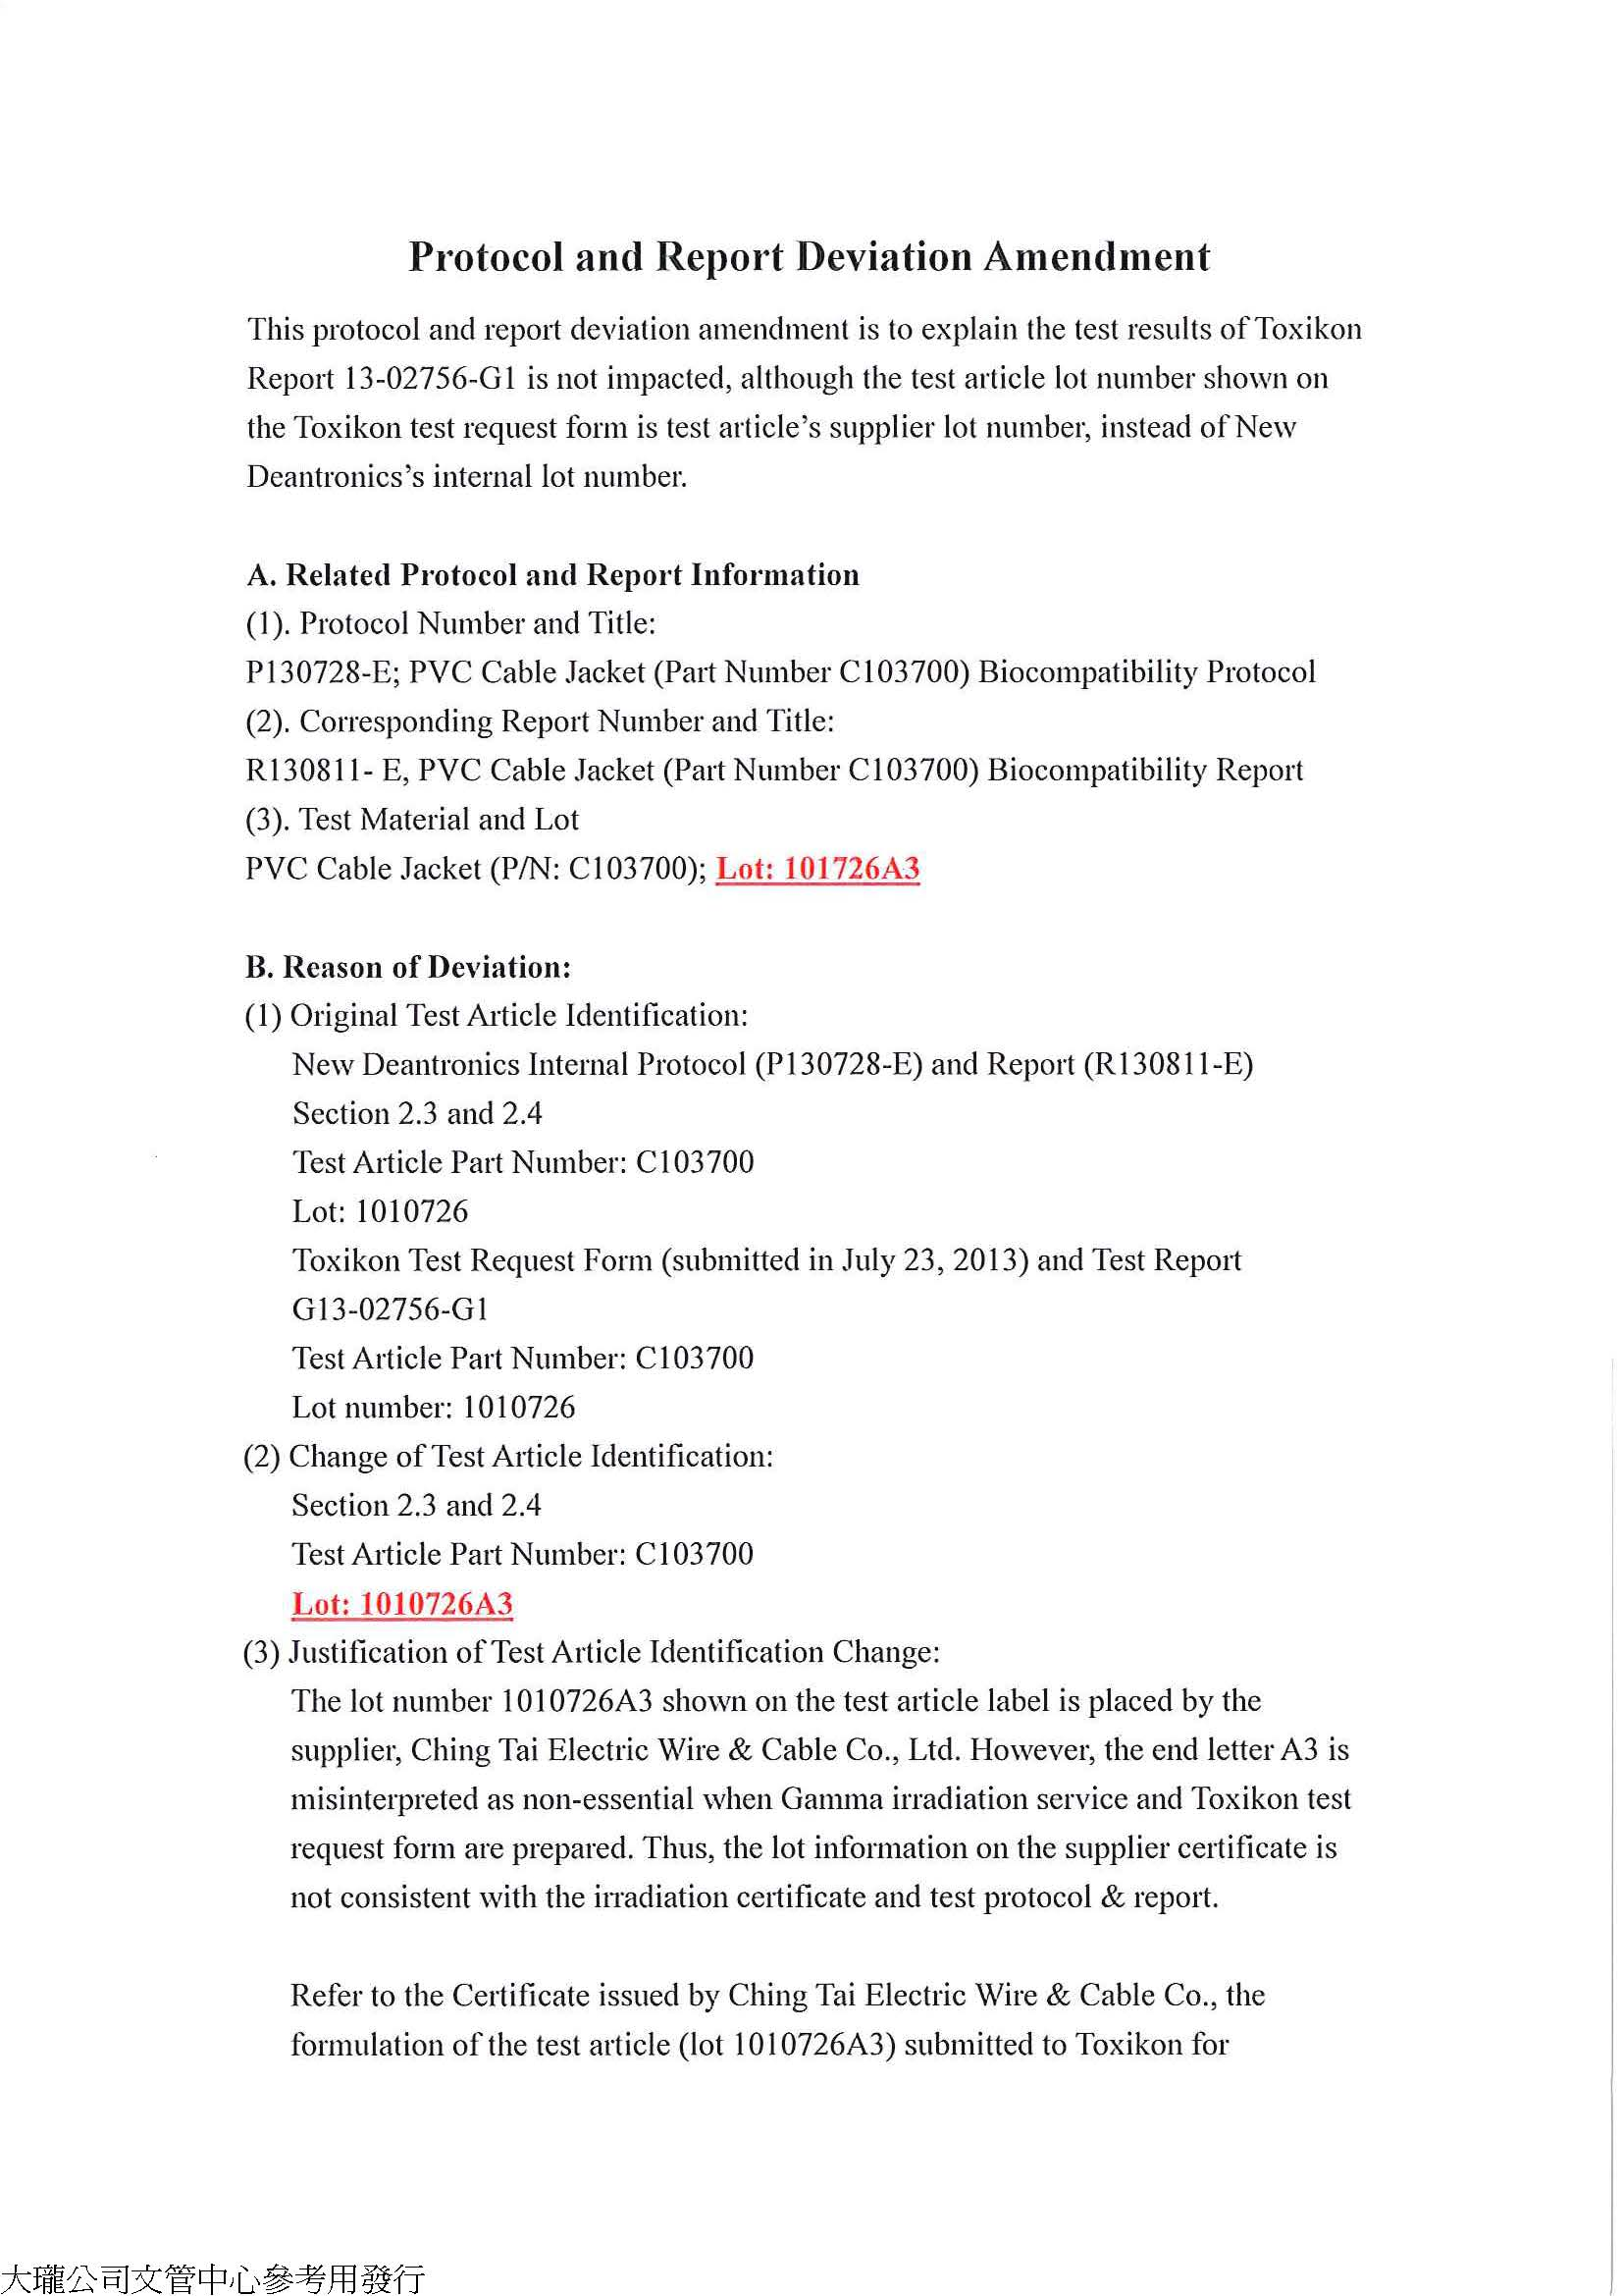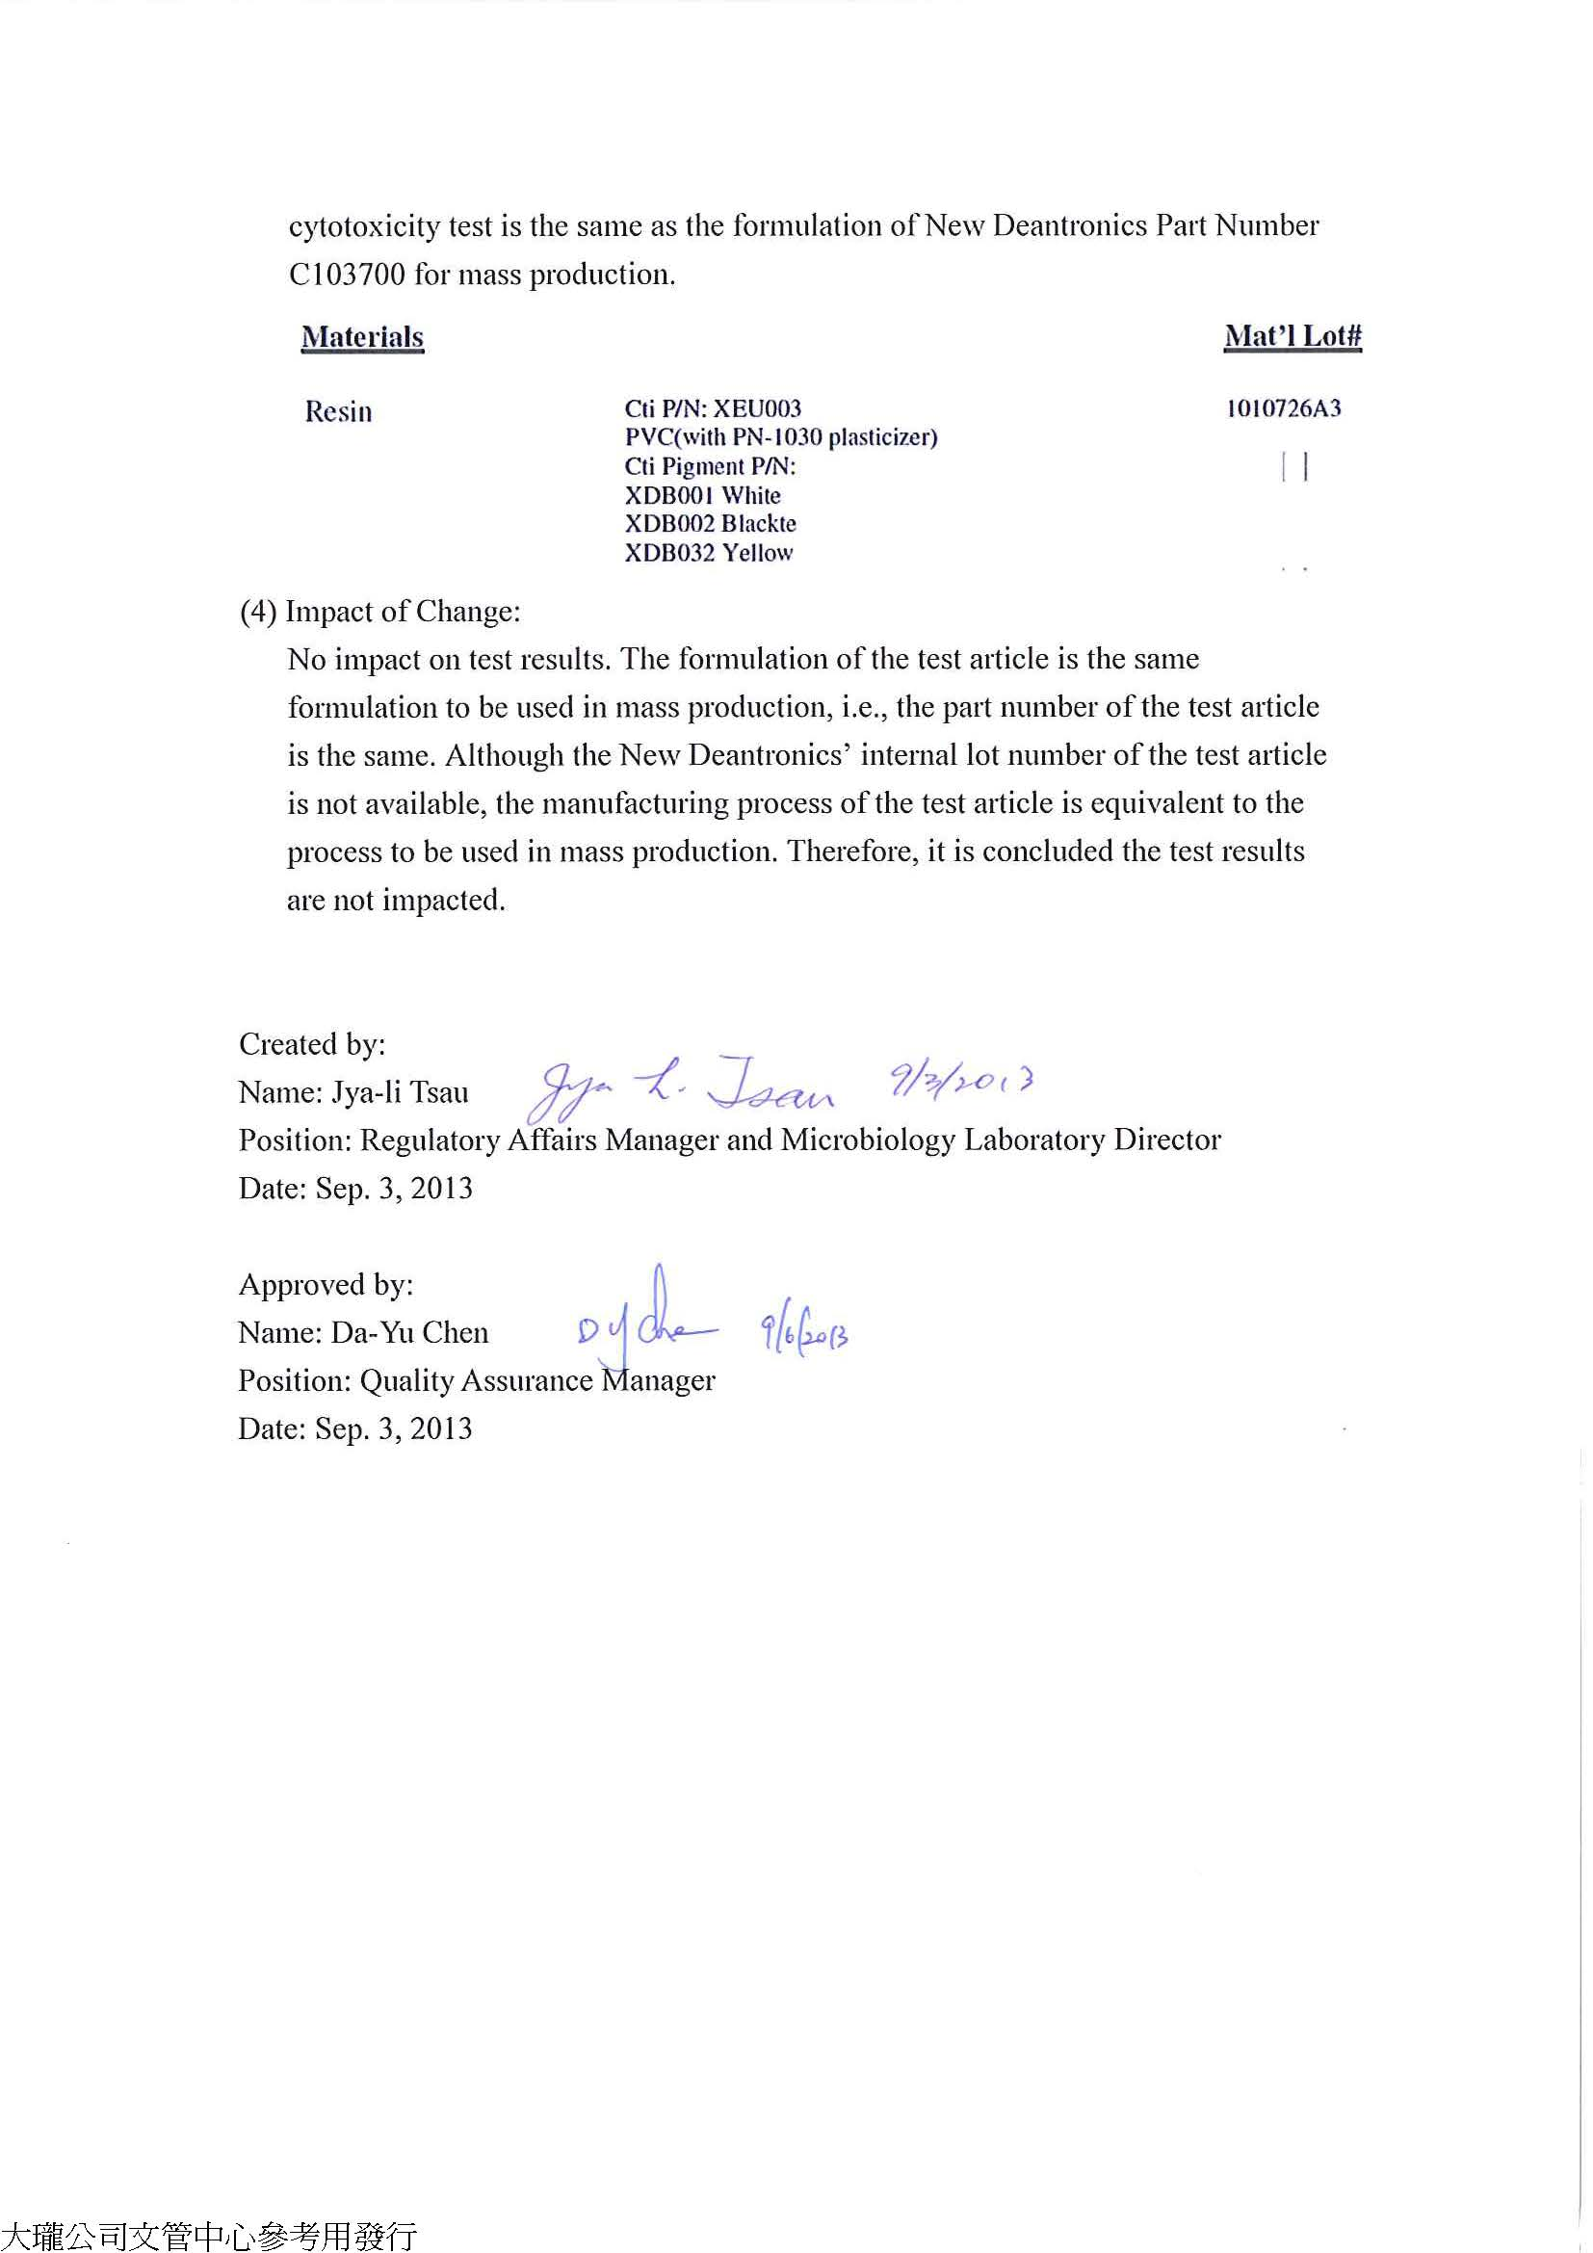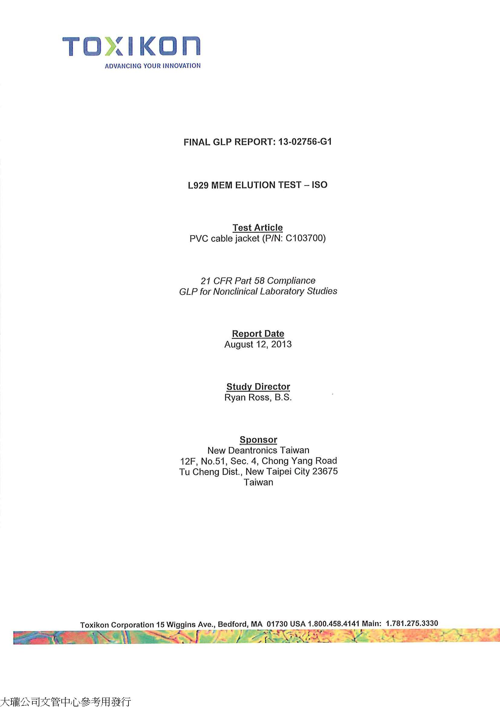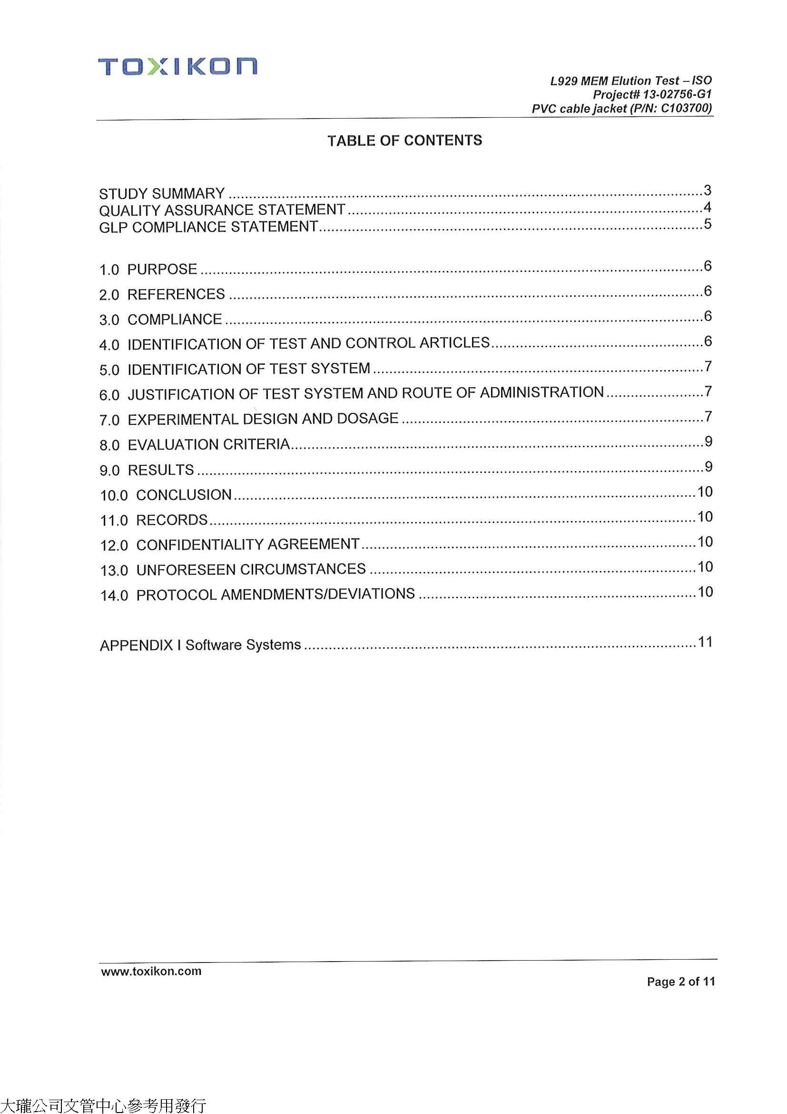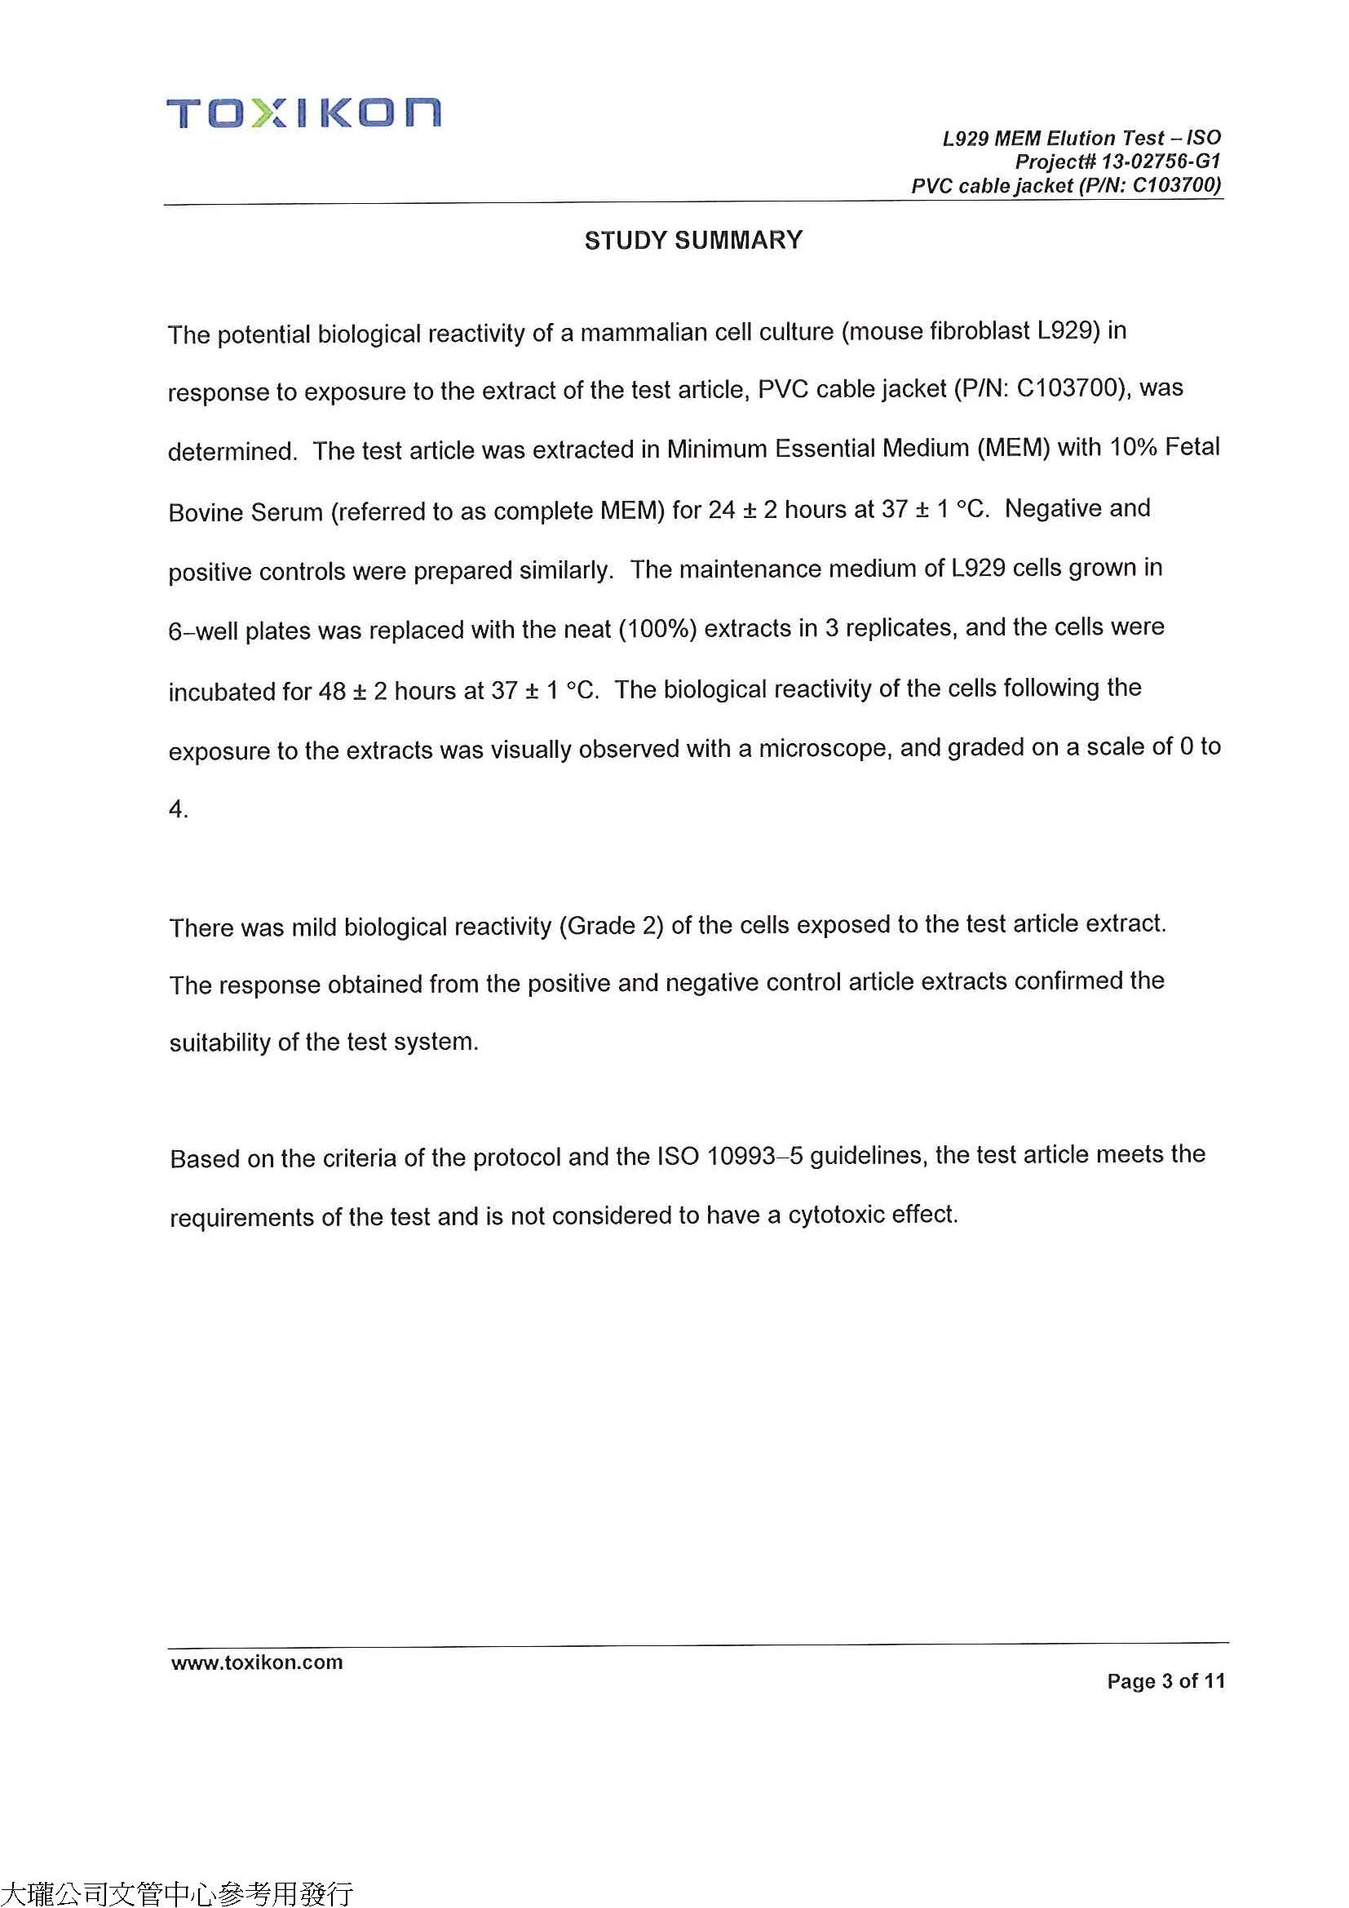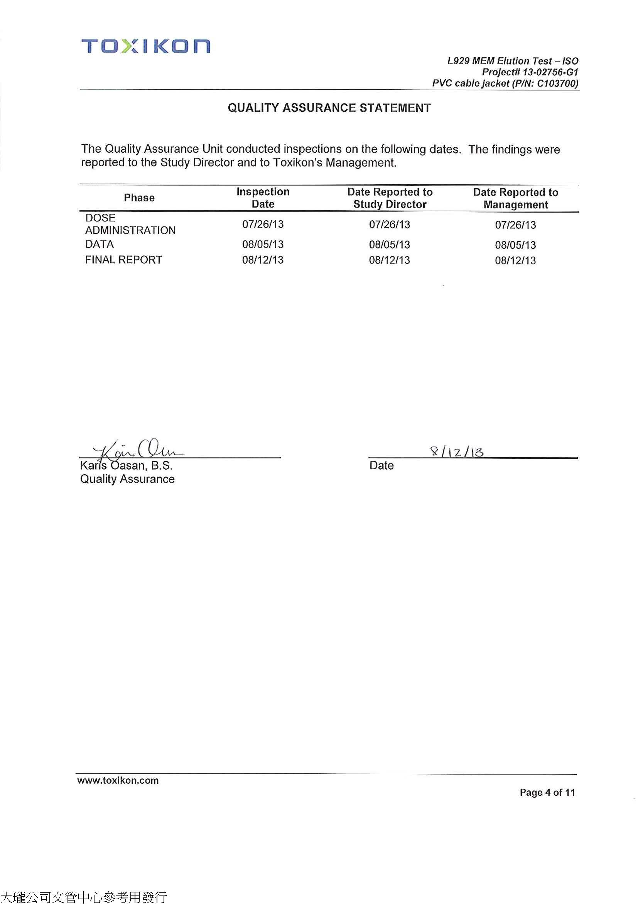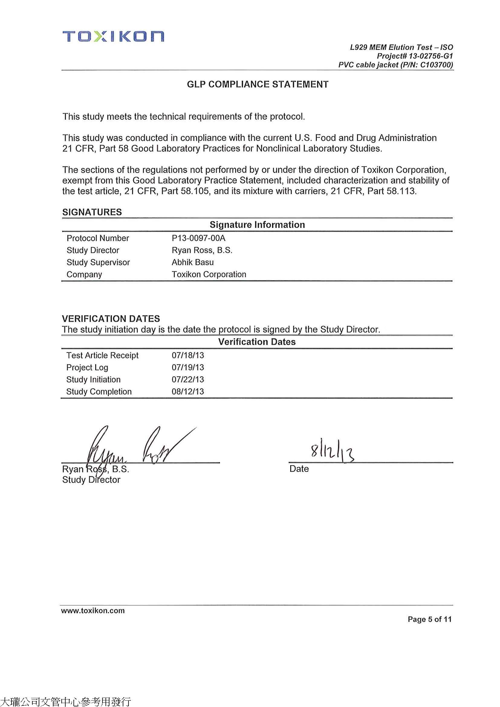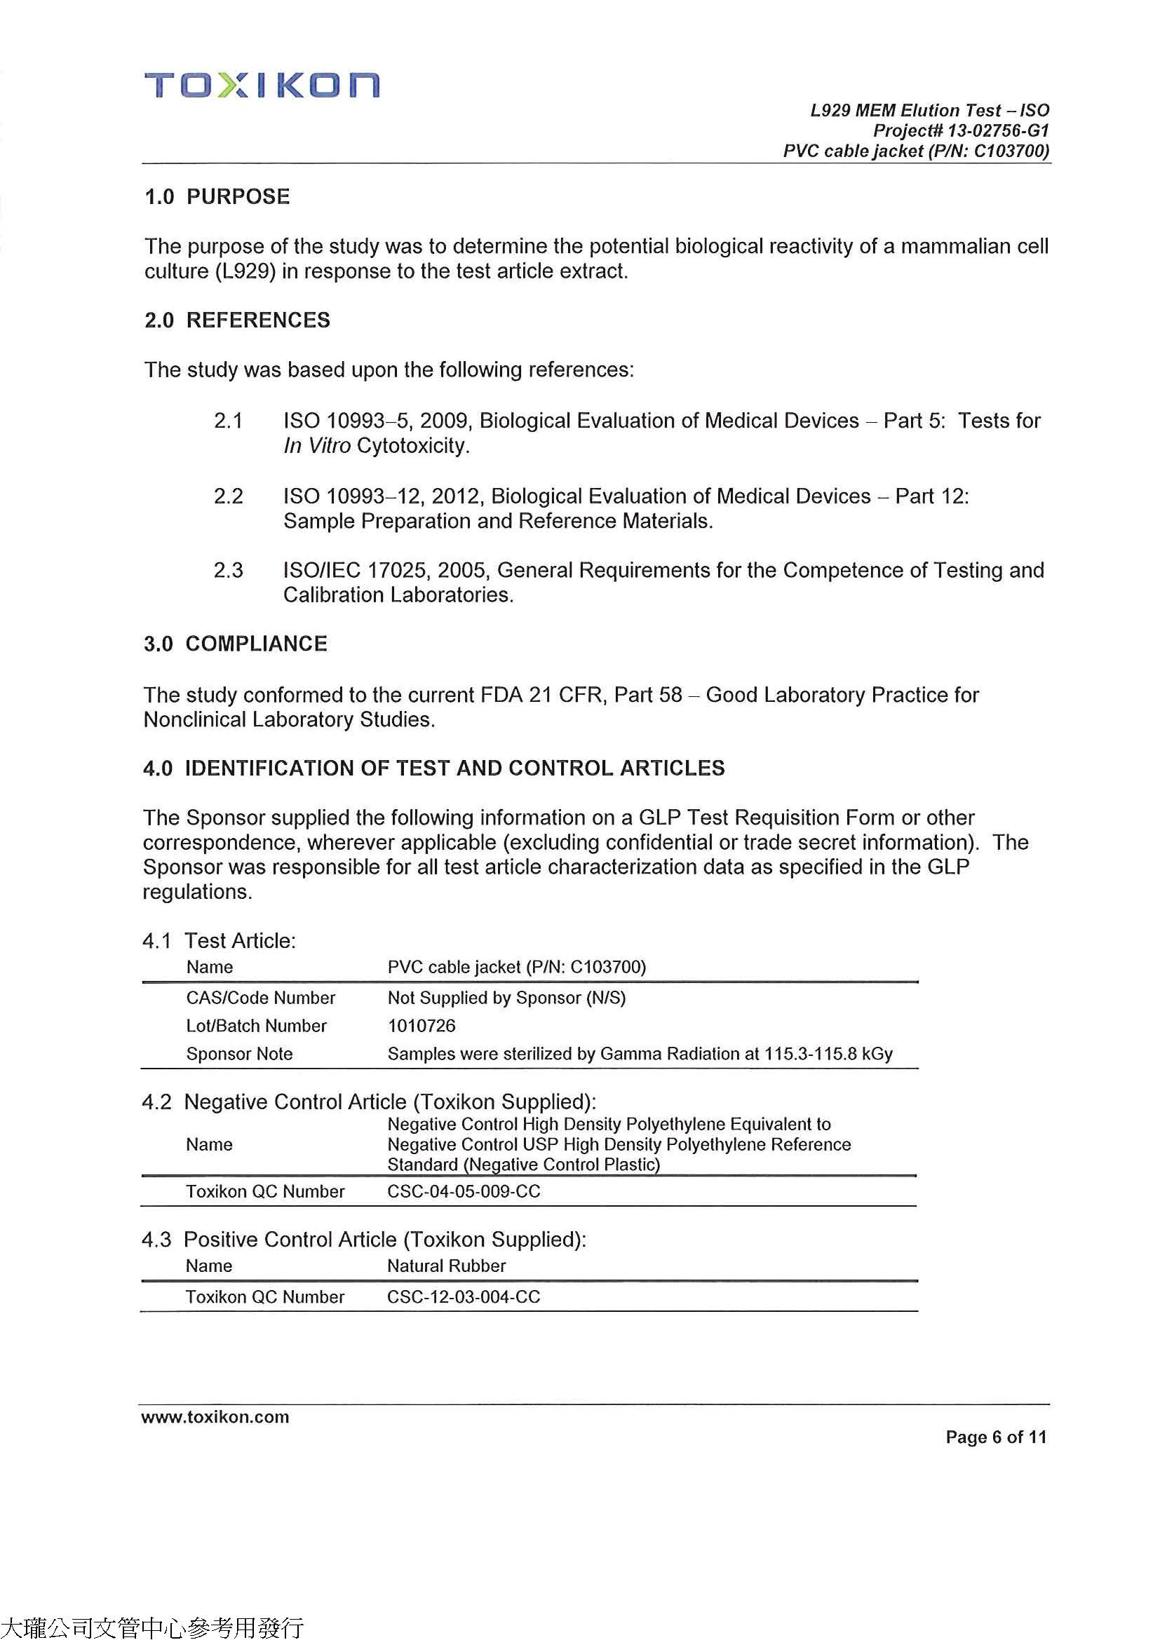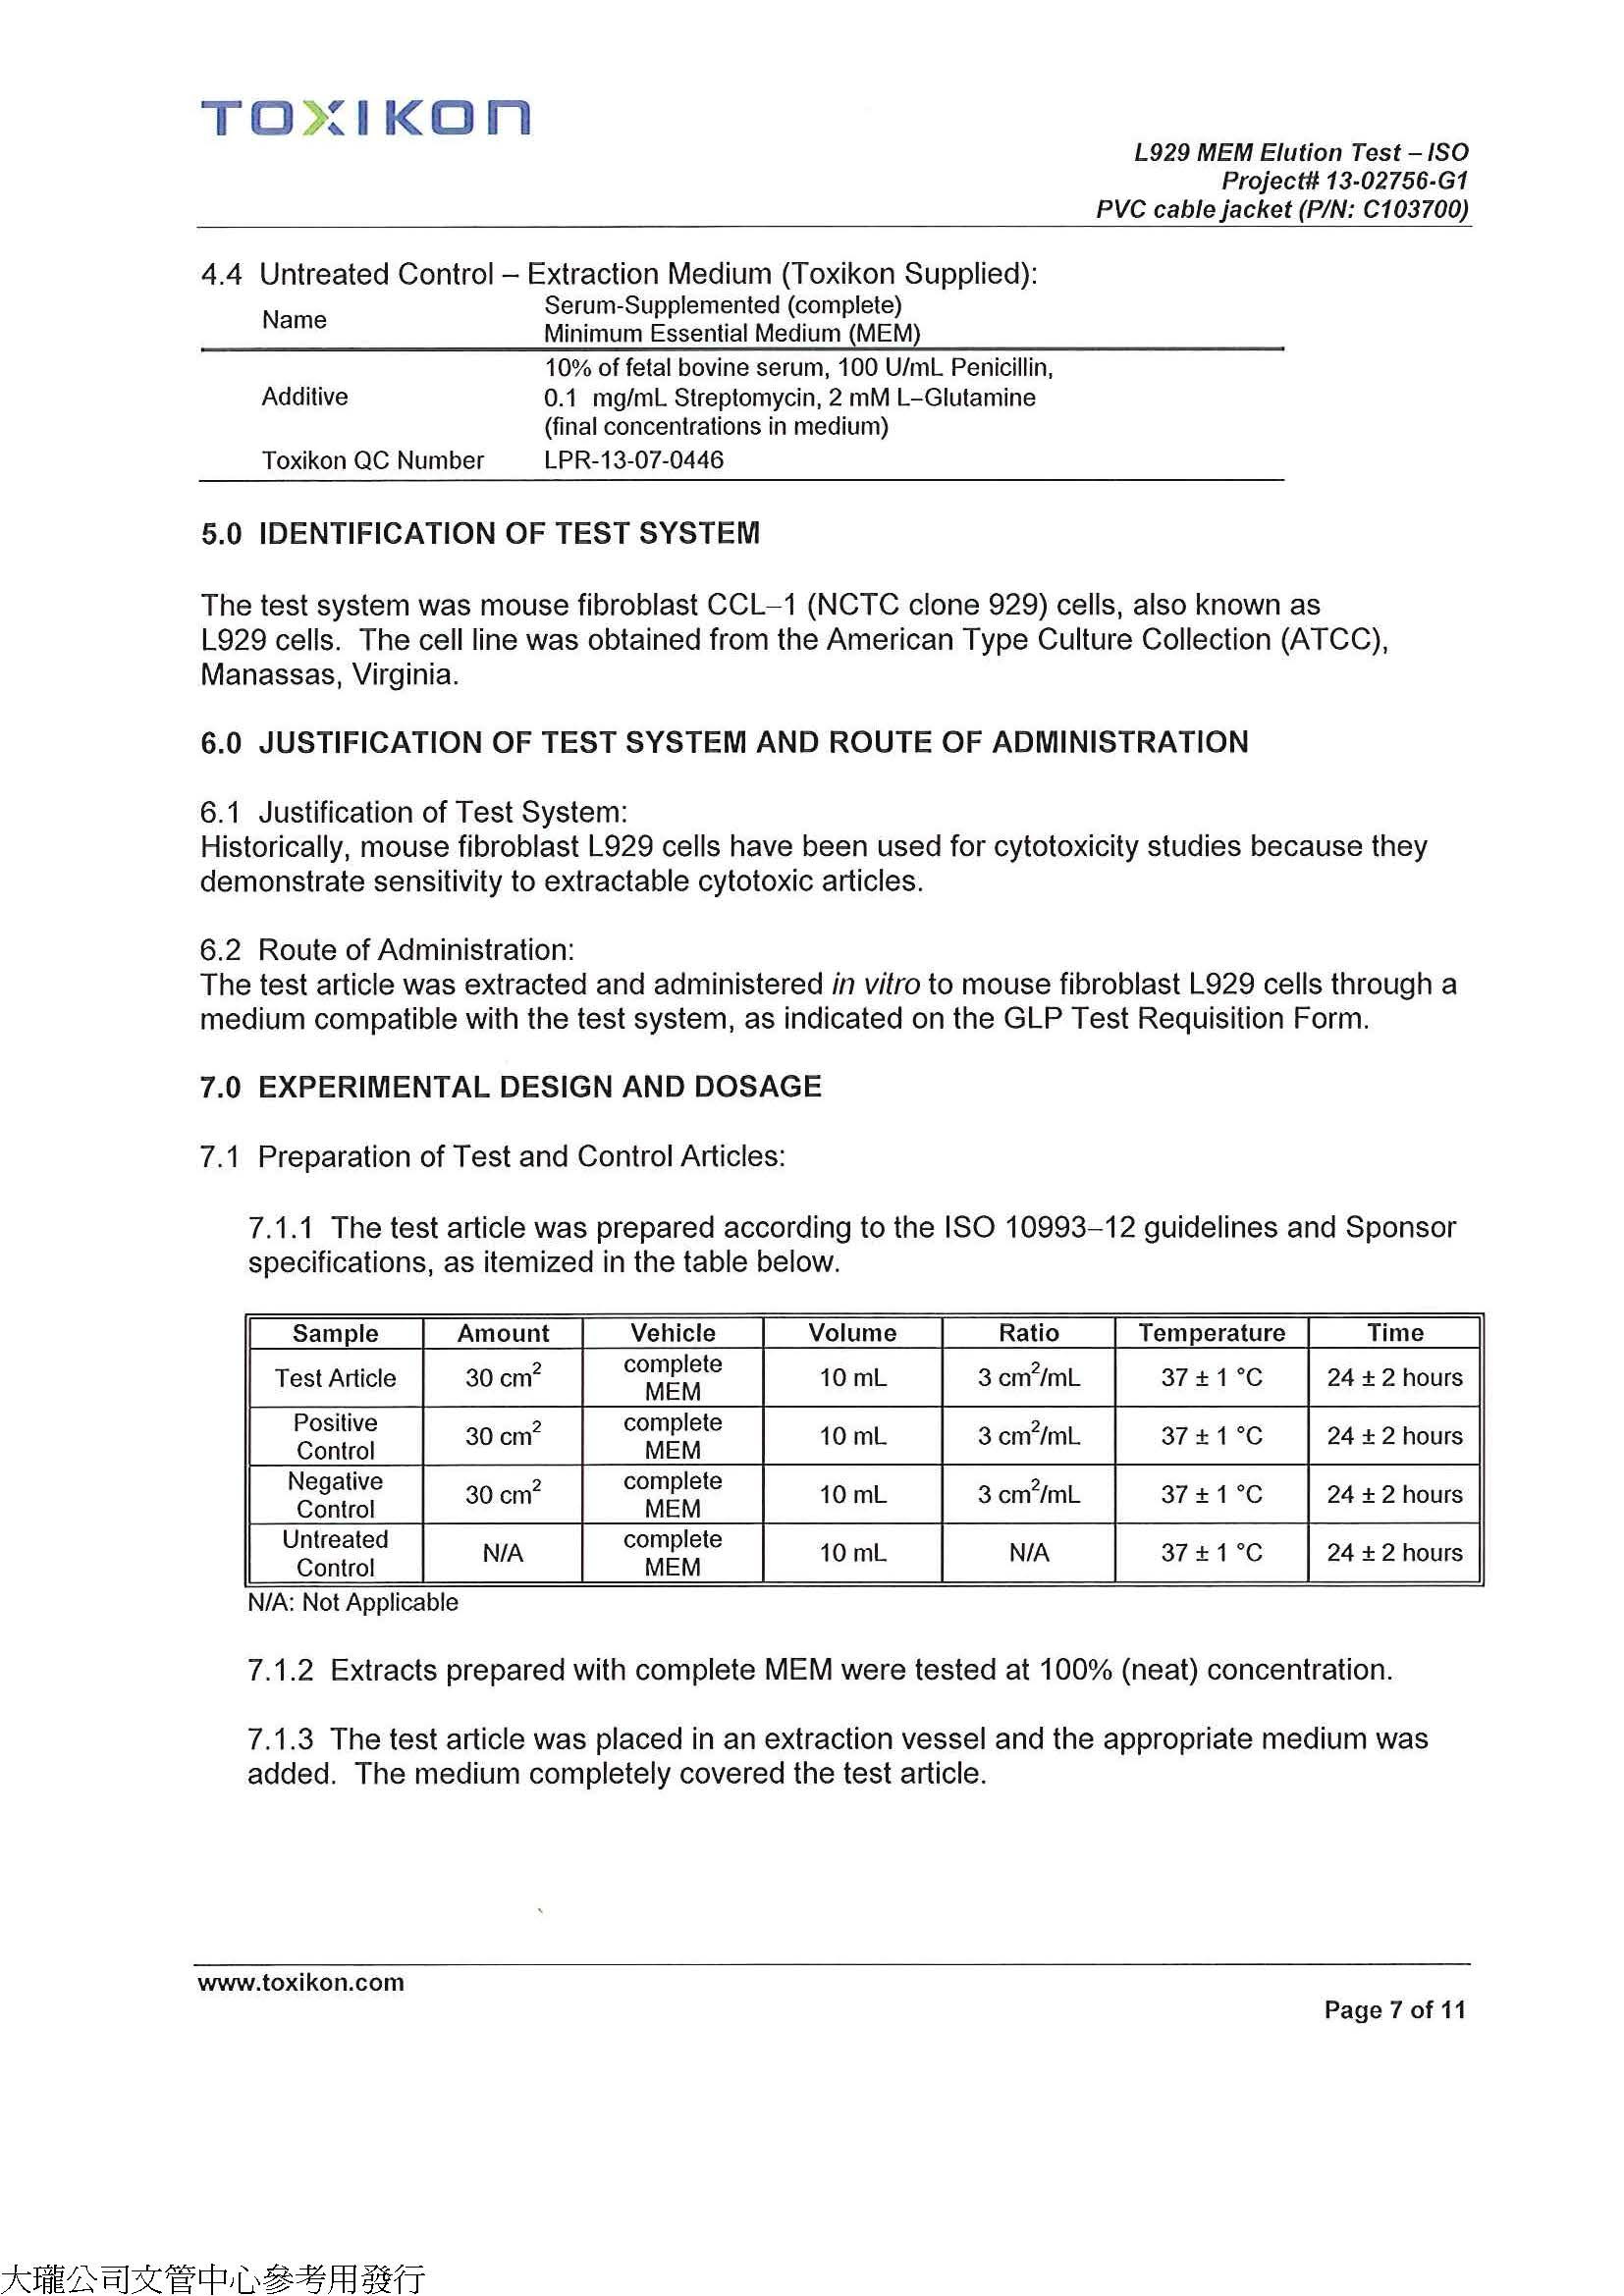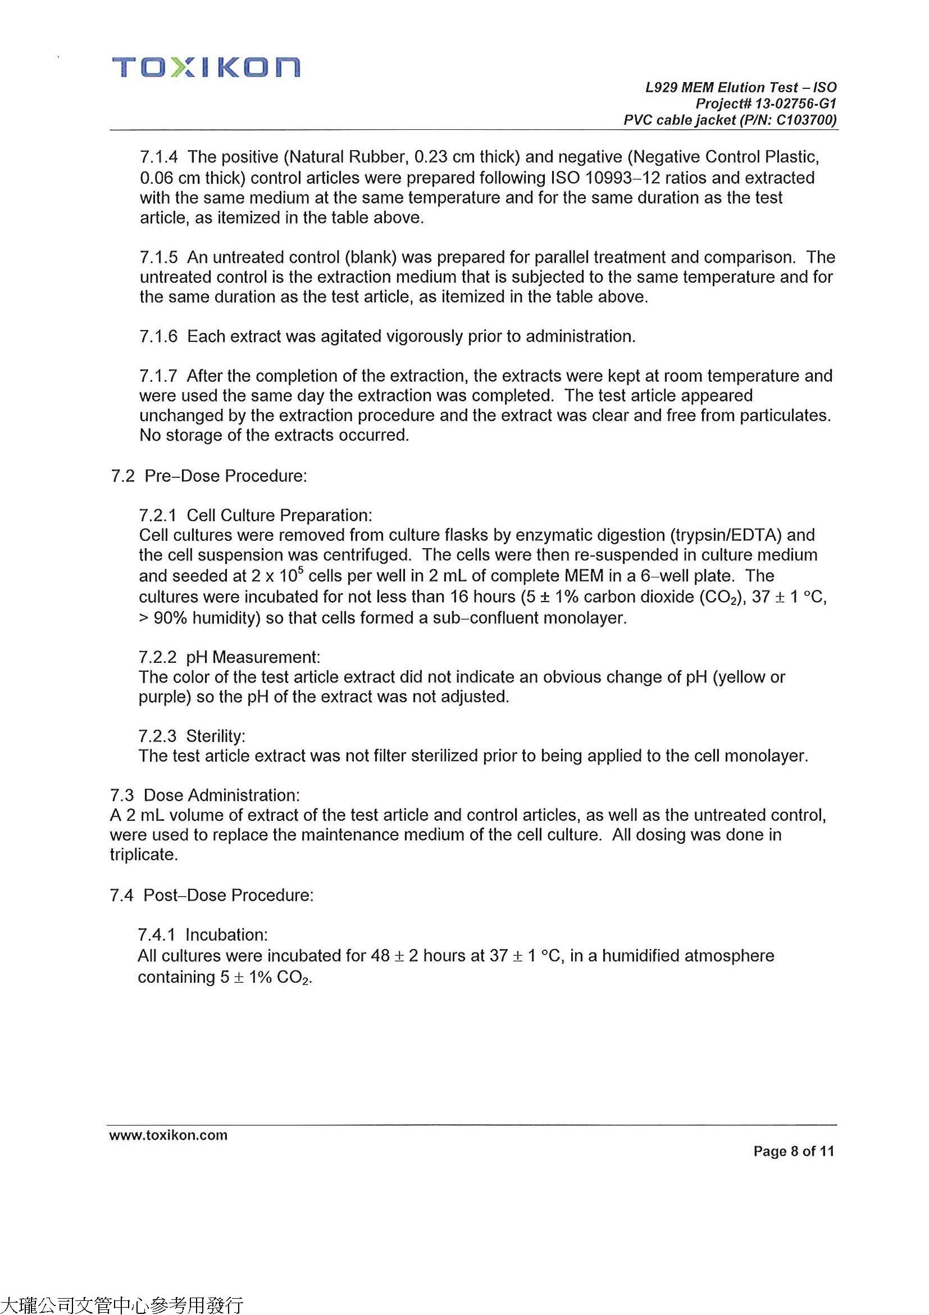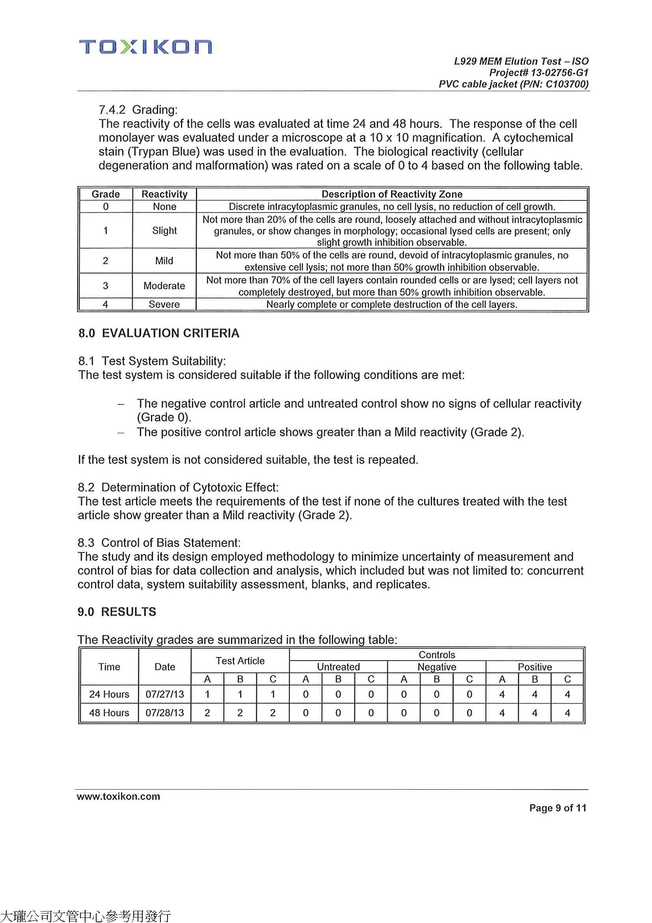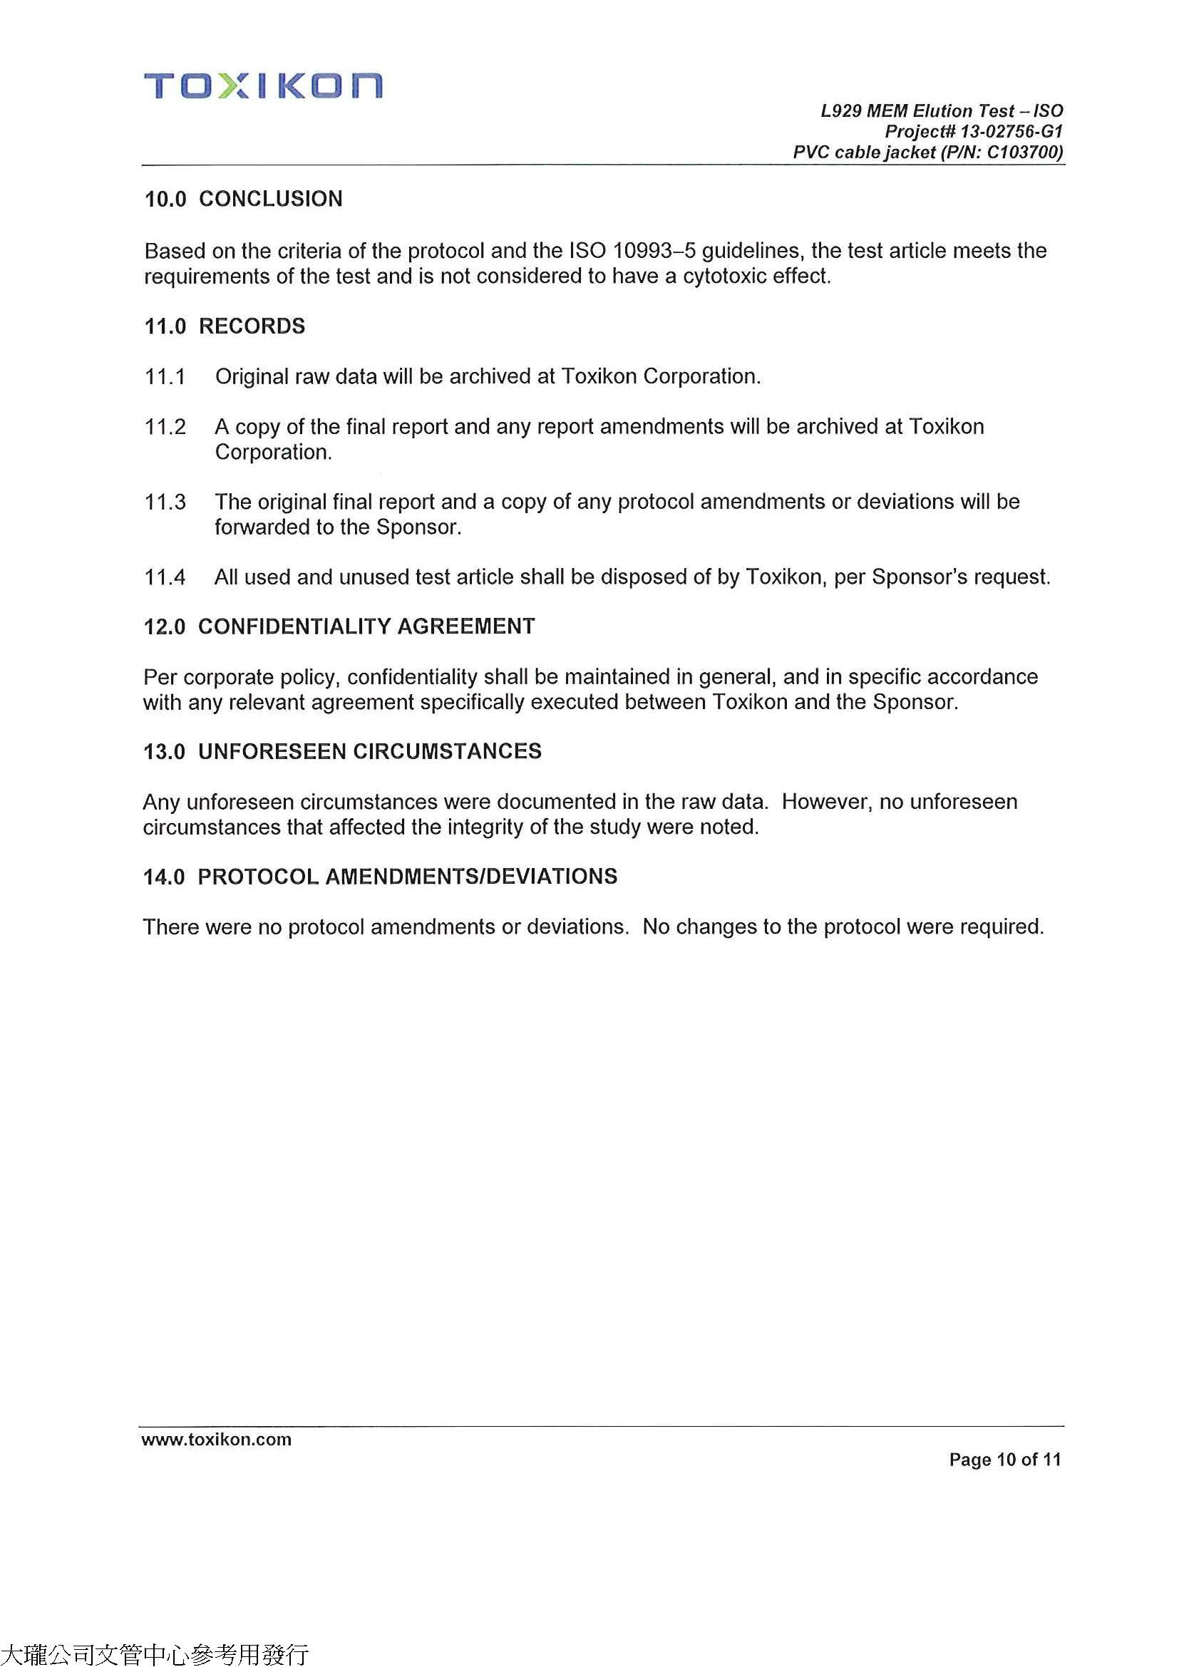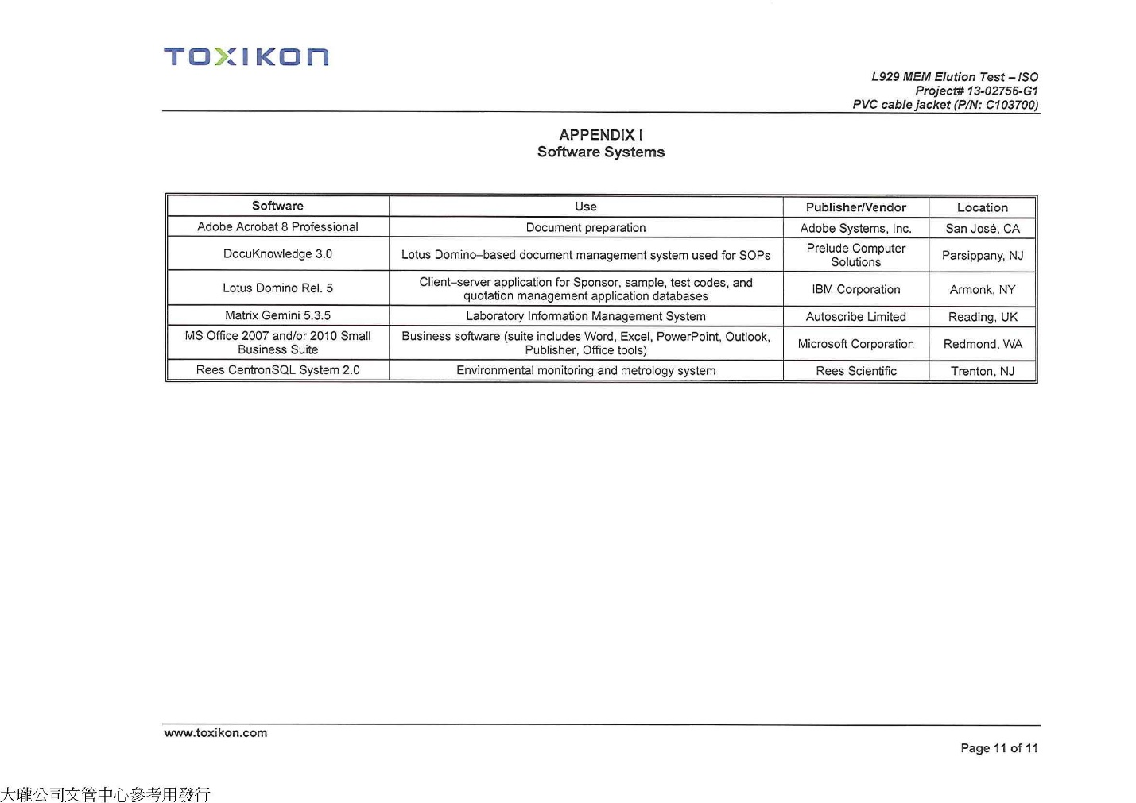

APPENDIX XIII. 2211 ULPA Filter Efficiency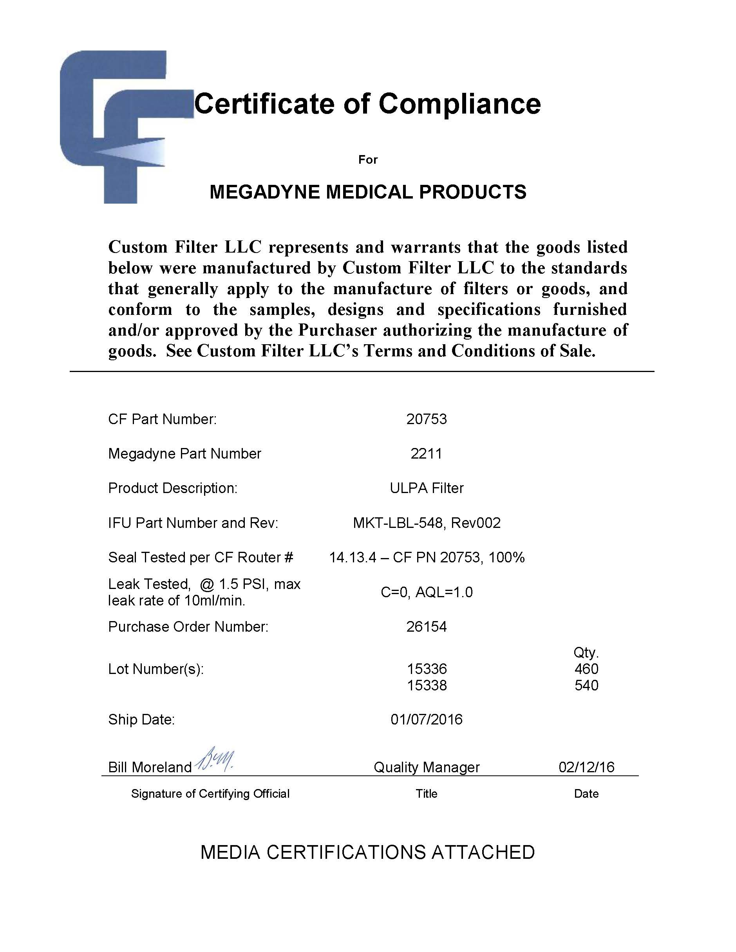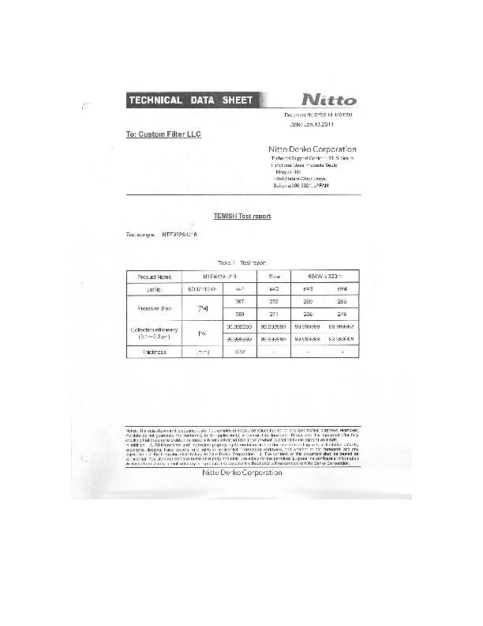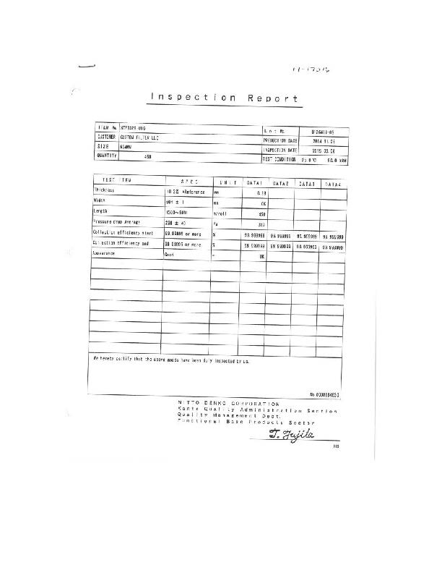

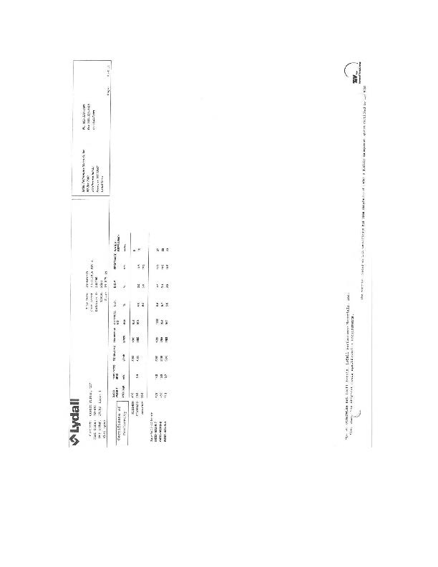

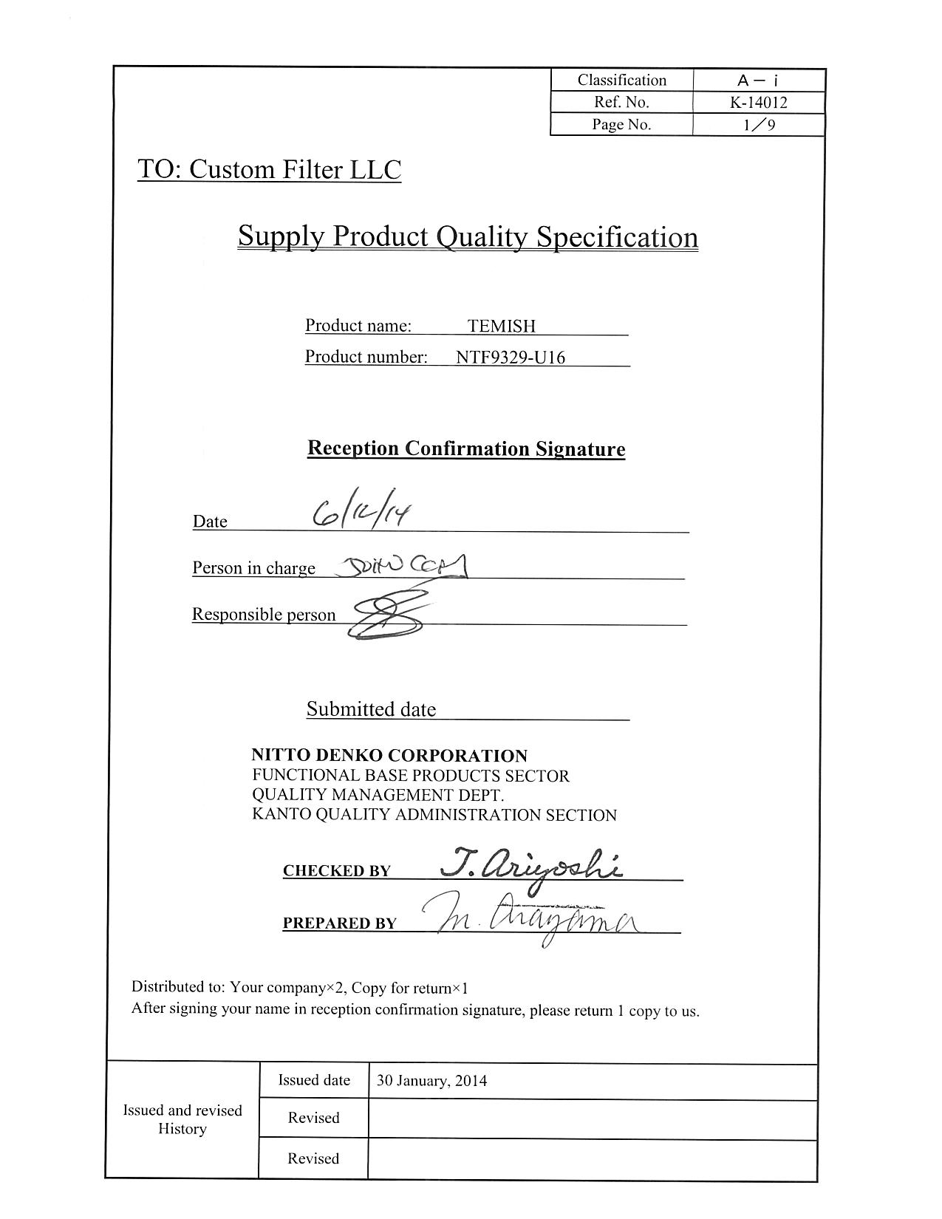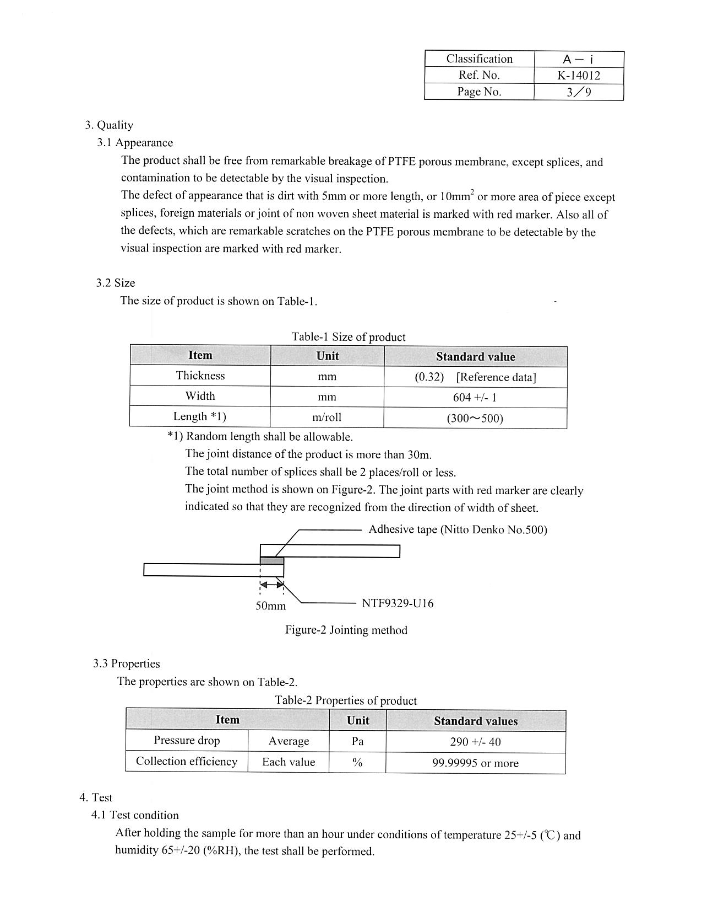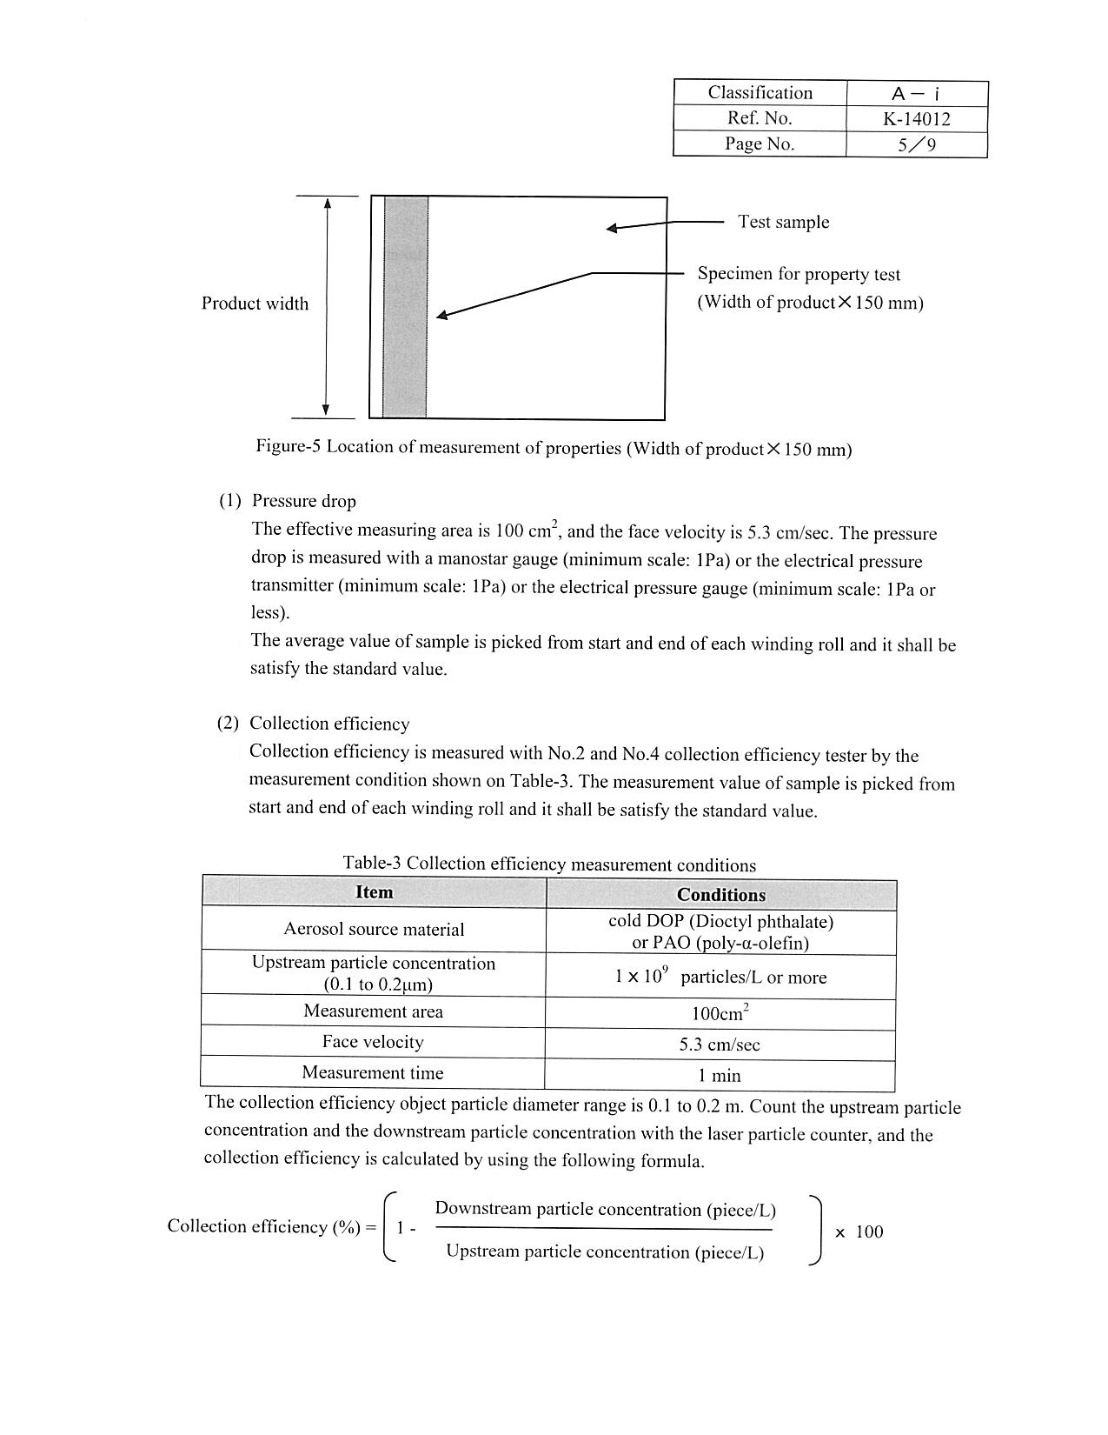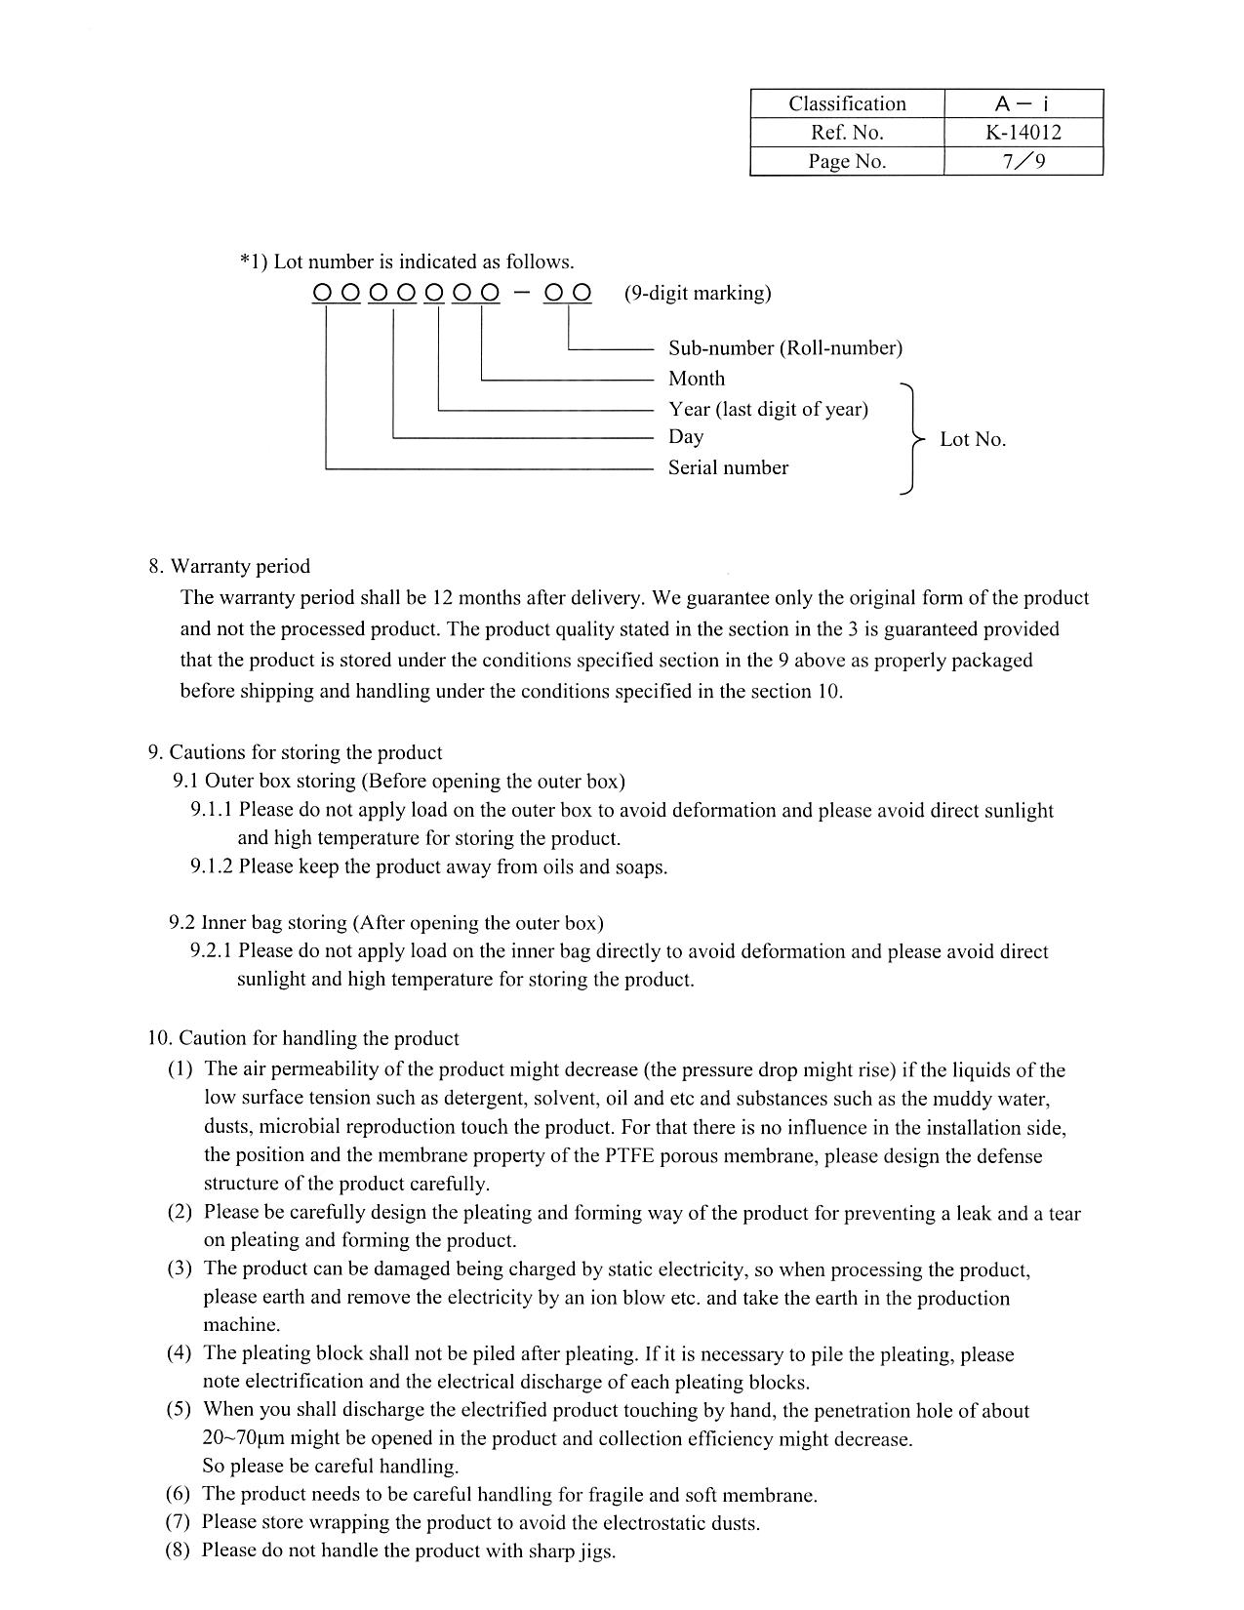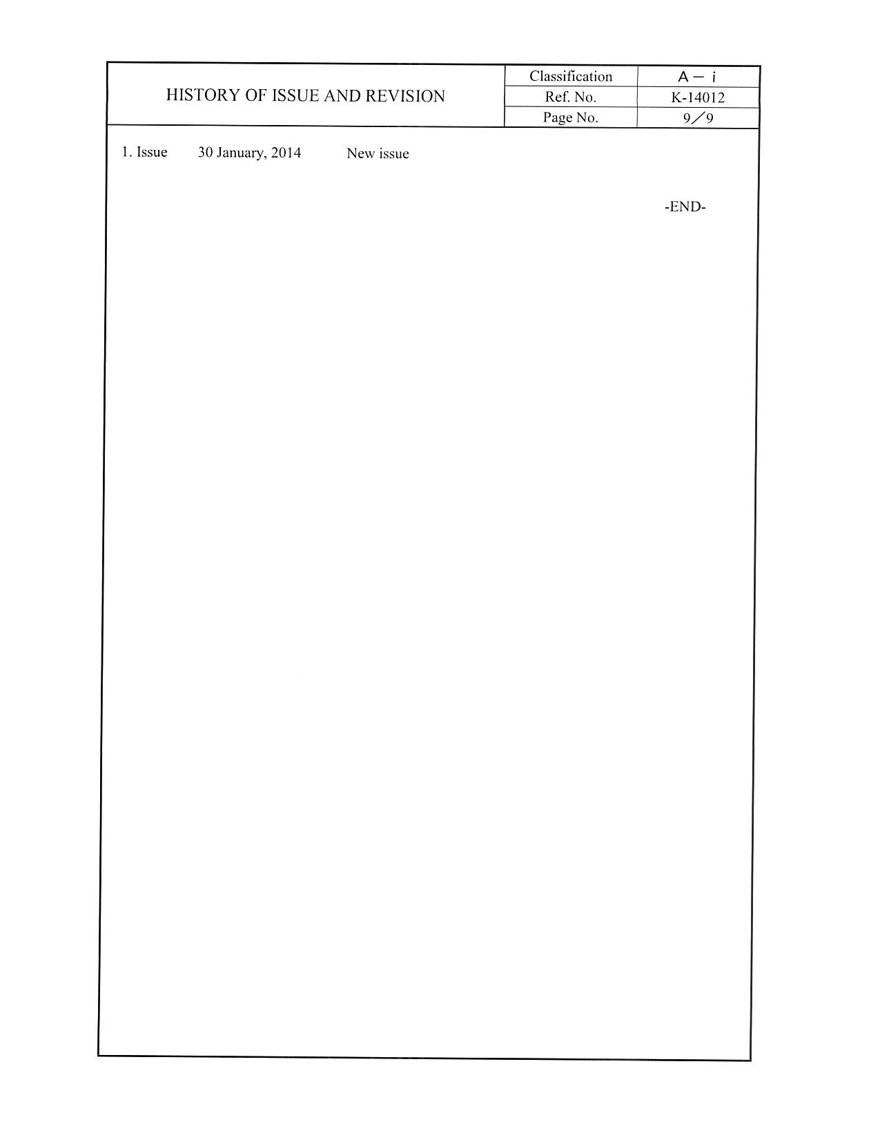

APPENDIX XIV. Training Record